TITLE OF THE PAPER HAS TO BE ADEQUATELY DESCRIBED THE CONTENT OF THE STUDY WITH MAXIMUM 20 WORDS
Firstname Lastname ¹, Firstname Lastname ² and Firstname Lastname ^{2, *}
- Affiliation-1: Address
- Affiliation-2: Address
* Correspondence: Email
Abstract: Abstract should be a single paragraph with maximum of 300 words. It must contain the statement of the problem or central issue that to be addressed, method of the research, qualitative/quantitative results which reflect the major finding or significance of the study.

Keywords: keyword 1; keyword 2; keyword 3 (At least three main topics or fields that are within the subject main discipline)

Introduction, Literature Reviews
The introduction should clearly describe the scope of the research work including the breadth and depth of the information that to be presented. Overview of the relevant literature must be provided to; describe the current state of art of the research topic; identify knowledge/research gaps; illustrate advancement in the proposed research work. Briefly mention the main aim of the work and highlight the principal conclusions.
References must be numbered in order of appearance and is indicated by a number in the square bracket such [1] or [1], [2], or [1]–[3].

Methodology
The research methodology should be described in a manner that the work can be replicated by others. Sufficient details on the employed materials and methods must be well described and appropriately cited. Any restriction on the availability of the information must be disclosed upon the submission stage.

Results & Discussion
The result and discussion section should present the results (graphical, tabulated data) and its scientific reasoning with concise and precise description including the significance of the findings. This section can be divided into multilevel subsections. There must be a preamble between the main section and subsection. This to introduce the subject of the main section and to ensure that the content flows coherently throughout the manuscript.
All Tables & Figures must be labelled with numbered caption along with short and concise title. Figure captions are placed below the figures, while table captions must be placed above the tables. All Tables & Figures must be cited in paragraph.

Subsection-first level
There must be a preamble between the subsection-first level and subsection-second level. This to introduce the subject of the subsection-first level and to ensure that the content flows coherently throughout the manuscript. At least two subsections of the first level are required in order to justify having the subsection.
    - Subsection-second level
At least two subsections of the second level are required in order to justify having the subsection. Avoid having subsection higher than the second level.

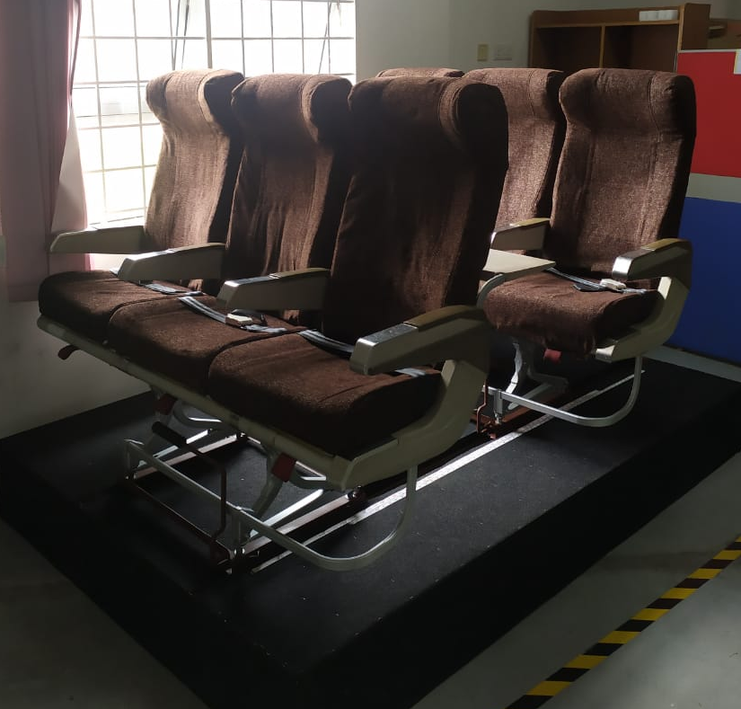
Figure 1: Title of Figure

Table 1: Data with Row and Column Titles
Title | Title Column-1 | Title Column -2 | Title Column -3
Title Row-1 | Data | Data | Data
Title Row-2 | Data | Data | Data
Title Row-3 | Data | Data | Data

- Conclusion
Conclusion should highlight the significance of the study and emphasize on the main finding of the research work. It should also acknowledge any limits and make suggestions for future research on the subject matter.
Acknowledgement
In this section, the name of the funder and the grant number or any other support given such as administrative and technical support, or donations in kind can be included.
References
All references must be cited in paragraph and is arranged based on the order that they appear in the manuscript. Kindly use bibliography software package (EndNote, Mendeley) to avoid any errors on the references.
[1] A. B. Author-1 and C. D. Author-2, ‘Title of the Article’, Name of the Journal, volume, issue, page range, year, DOI
[2] A. B. Author-1, C. D. Author-2, E. F. Author-3, and G. H. Author-4 ‘Title of the Article’, Name of the Journal, volume, issue, page range, year, DOI
[3] A. B. Author-1 and C. D. Author-2, ‘Title of the Book’, Edition, Publisher, year, DOI

