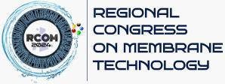

Impiana Hotel Senai in Johor Bahru 30 September – 1 October 2024
https://research.utm.my/amtec/rcom2024/

Details of Sponsorship

Name of Company
Website
Contact Person’s Details
(a) Name
(b) Position
(c) Email Address
(d) Phone
Sponsorship (Please
tick) | (a) Gold Sponsorship (RM 5000)
 | (1 booth, corporate video during conference, event registration with grand dinner for 2 pax)
 | (b) Silver Sponsorship (RM 3000)
 | (1 booth, corporate video during conference, event registration with grand dinner for 1 pax)
 | (c) Bronze Sponsorship (RM 2000)
 | (Event registration with grand dinner for 1 pax)
 | (d) Normal Sponsorship (RM 500)
Note: Invoice will be issued once we have received your sponsorship form.

Signature:
Name:
Date:

Please submit the completed sponsorship form to rcom2024@utm.my and our sponsorship unit will contact you in due course.

