iMEDiTEC2023 CMT Submission Guidelines

Step 1:
Please go to https://bit.ly/iMEDiTEC2023 or click the following link
MICROSOFT CMT
*Click “Register” for the new user.
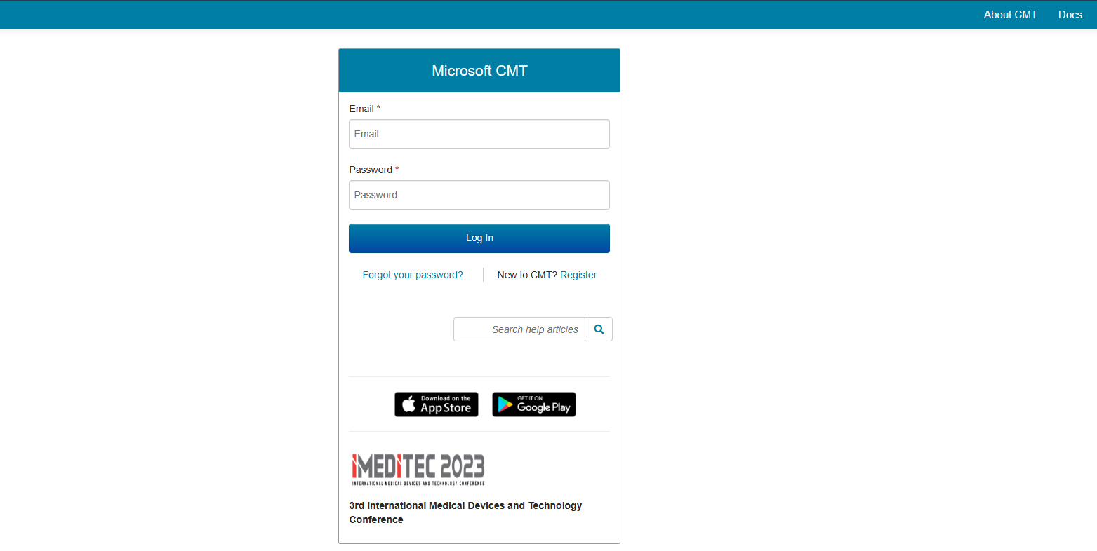

Step 2:
Click “Create new submission” and select the “track”.
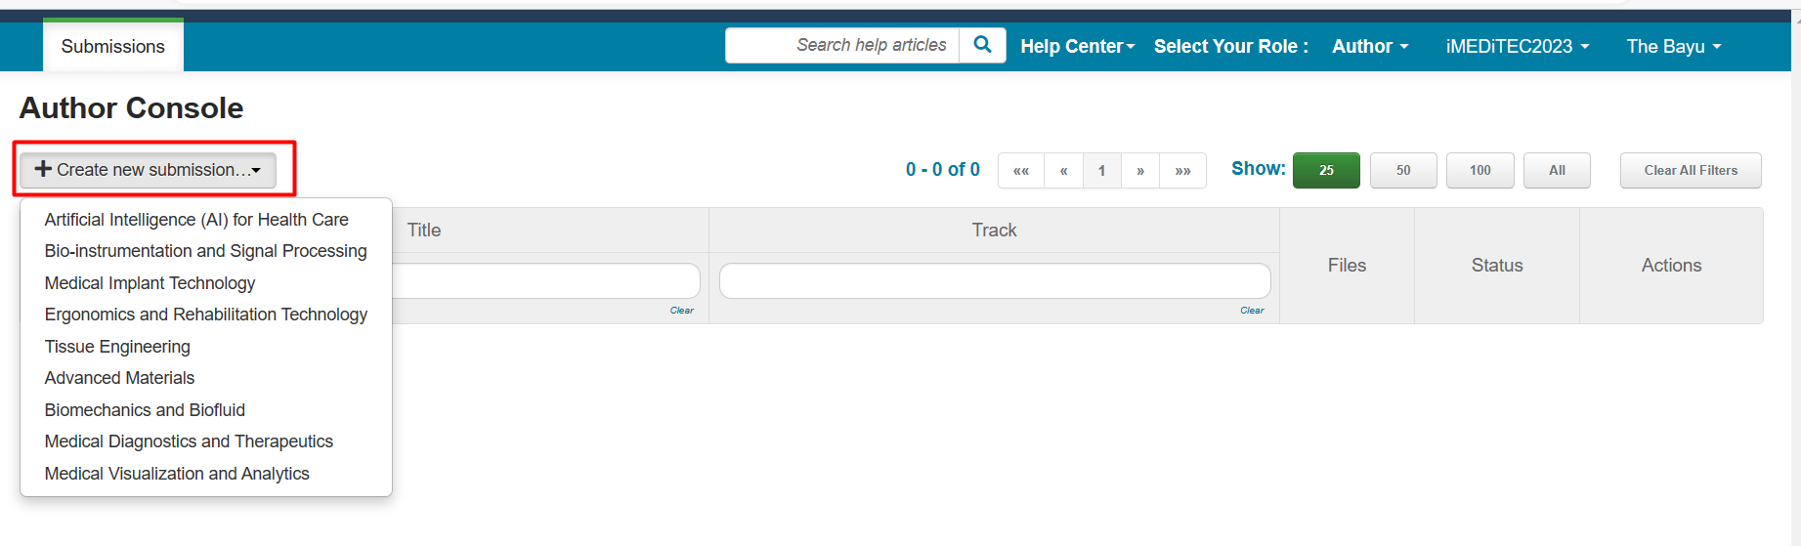

Step 3:
Fill in all required fields, i.e. Title, Abstract and Authors information.
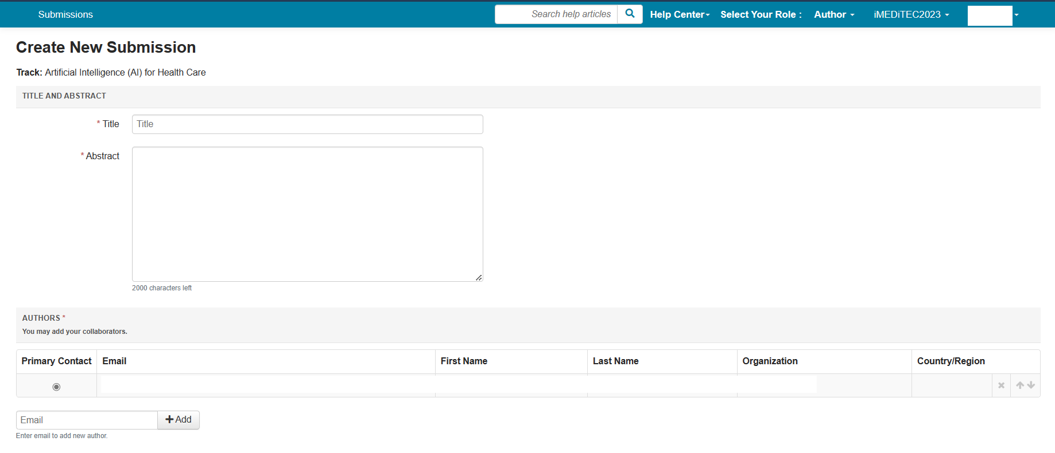

Step 4:
Upload your manuscript.
**Please note that the manuscript submitted to this conference should be in word file ONLY (format extension .doc or .docx)
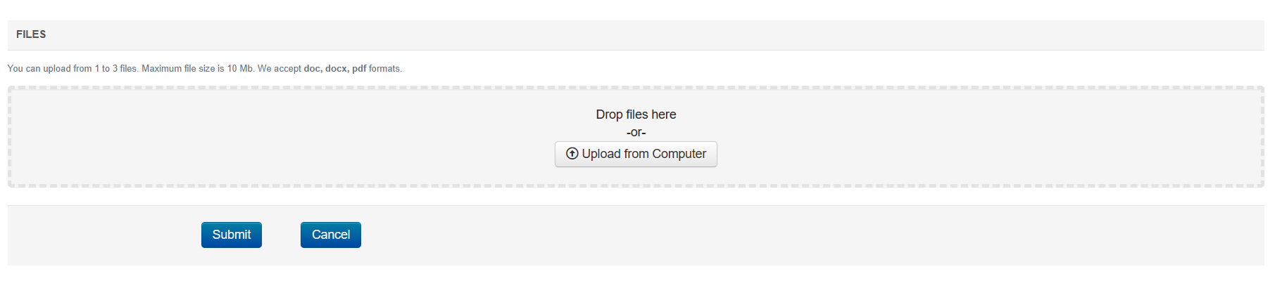

Step 5:
- Click “Submit” to submit your manuscript

