ONE-PAGE EXTENDED ABSTRACT FOR 2018 MYHVNET COLLOQUIUM

N. Azis^{1,}*, Co-Author² and Co-Author²
¹Faculty of Engineering, Universiti Putra Malaysia, 43400 Serdang, Selangor, Malaysia.
²Universiti Teknologi Malaysia
*E-mail: norhafiz@upm.edu.my

Abstract - The abstract should be not more than 250 words and must be written in English. At least 5 keywords should be included at the bottom of the abstract. The abstract should give a clear indication of the objectives, scope, results and conclusion of your work.

Keywords – Extended Abstract, Introduction, Methodology, Results, Discussion

INTRODUCTION

The template is supplied with the correct style set. The text can just be replaced with your own work. Generally, the introduction part may contain background of the work, problem statement, literature review, objectives of the study and etc. The references should be cited in the text in numbering style and must be referred in the references part.

METHODOLOGY

Please follow the guidelines below when formatting the paper:
- Maximum 1 page ONLY
- Paper format: standard A4
- Justified text and two-column layout.
- Top and botom margin 2 cm
- Left and right margins of 2 cm each.
- Font and size: Times New Roman 10 pt, single line spacing.

RESULTS AND DISCUSSION

The results and discussion section presents the findings of the authors. Authors are encouraged to highlight their achievements. Appropriate figures may be included. A figure caption should be included below the figure.
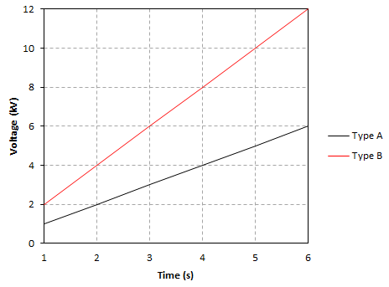
Figure 1: Voltage characteristics.

CONCLUSIONS

All extended abstracts (in pdf format) should be e-mailed to Dr. Norhafiz Azis (norhafiz@upm.edu.my) by mentioning 2018 MyHVnet Colloquium Abstract as the subject of the e-mail.

ACKNOWLEDGEMENTS

Please acknowledge appropriate sources of funding.

REFERENCES

IEEE reference formats must be used. Examples are as follows :
- A. Vetro, H. Sun, P. DaGraca, and T. Poon, “Minimum drift architectures for three-layer scalable DTV decoding”, IEEE Trans. Dielectr. Electr. Insul, Vol. 44, pp. 527-536, 1998.
- A. N. Netravali and B. G. Haskell, Digital Pictures, 2nd ed., Plenum Press: New York, pp. 613-651, 1995.

