CHAPTER 1

Real-time with Load Distributed Routing Protocol in Wireless Sensor Networks

Ahmad Shahrin Ramli, Siti Zulfarina Fadzli, and Hassan Ali

  - Introduction 2
  - Related Works 3
    - Related Works 3
  - Result and Discussion 3
  - Conclusion 4

1.1 INTRODUCTION

The Wireless Sensor Network (WSN) is a wireless ad hoc network that consists of a very large number of sensor nodes which are densely deployed either inside an event area or in close proximity as shown in Figure 1.1. The advantage of using the WSN is that enables reliable monitoring and carries out an analysis of the physical environment. It is very different from the traditional networks as it comprises a large number of nodes that produces a very large amount of data. However, WSNs are not free of constraints which are related to power, computational capacities, and memory. Due to these inherent properties, conventional management schemes are not appropriate to manage these sensored network and therefore there is the need for a new management scheme.
Real-time communication is necessary in many WSN applications. For example, in a fire fighting application, immediate and appropriate action should be applicable in the area where the disaster occurs without any delay to prevent further damage. The data collected and delivered by the sensor must be accurately valid and without any delay at the time of decision making since inaccurate data and late delivery of data may endanger the lives of fire fighters.

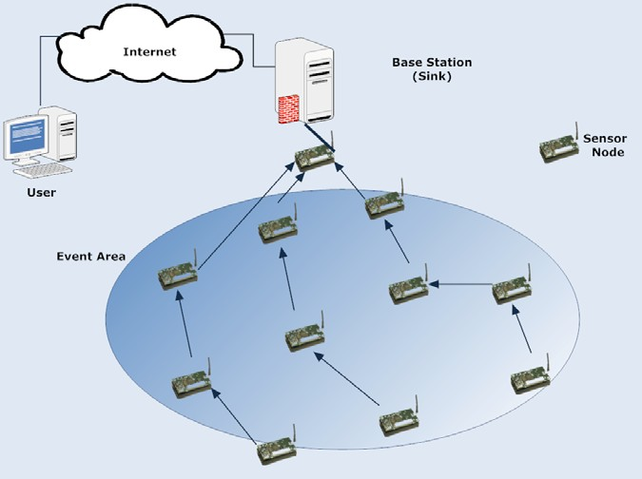

Figure 1.1 WSN architecture with MICAz motes. WSN applications must operate for on a long term basis without any wired power supplies

General research challenges for multi-hop routing in WSN arise primarily due to the large number of constraints that must be simultaneously removed. One of the most important constraints on sensor nodes is the requirement for power consumption. Sensor nodes carry limited as well as generally irreplaceable power sources. WSN applications must operate for on a long term basis without any wired power supplies and also not requiring the replacing nor recharging of the batteries. Therefore power consumption is an important factor to be taken into consideration while designing the multi-hop routing in order to prolong the lifetime of the WSN.
This chapter is organized by firstly presenting related work in Section 1.2. Section 1.3 describes the proposed system design while Section 1.4 explains the simulation study. Section 1.5 discusses the test bed study and finally, Section 1.6 of this chapter provides the conclusion/s drawn on the study.

1.2 RELATED WORKS

A comprehensive review of the challenges and the state of the art of real-time communication in sensor networks can be found in. A routing protocol based on link quality is proposed in the expected transmission count metric (ETX) is developed as the function of a metric is to select the forwarding node.

1.2.1 Related Works

ETX finds paths with the minimum expected number of transmissions to deliver a packet to its destination. The metric predicts the number of retransmissions required by using per- link measurements of packet loss ratios in both directions of each wireless link. The primary goal of the ETX design is to find paths with high throughput, despite losses. However, ETX does not consider the remaining power as an end-to-end deadline.

1.2.1.1 Related Works

ETX finds paths with the minimum expected number of transmissions to deliver a packet to its destination. The metric predicts the number of retransmissions required by using per- link measurements of packet loss ratios in both directions of each wireless link. The primary goal of the ETX design is to find paths with high throughput, despite losses. However, ETX does not consider the remaining power as an end-to-end deadline.

1.2.1.1.1 Previous Study

ETX finds paths with the minimum expected number of transmissions to deliver a packet to its destination. The metric predicts the number of retransmissions required by using per- link measurements of packet loss ratios in both directions of each wireless link. The primary goal of the ETX design is to find paths with high throughput, despite losses. However, ETX does not consider the remaining power as an end-to-end deadline.

1.3 RESULT AND DISCUSSION

To create a realistic simulation environment, we have simulated RTLD based on the characteristics of the MICAz mote from Crossbow. RTLD is simulated and compared to the existing real-time routing protocol. Table 1.1 shows the simulation parameters used to simulate RTLD in Network Simulator-2 (NS-2). In this table and IEEE 802.15.4 MAC physical layers are used. Many-to-one traffic pattern is used which is common in WSN applications. This traffic is typical between multiple source nodes and a sink. In all simulations, each node updates its neighbour table every 180s. In this work, 121 nodes are distributed in a 100 m × 100 m region as shown in Figure 1.3. Nodes numbered as 120, 110, 100 and 90 are the source nodes and node 0 is the sink.

Table 1.1 Simulation parameters used to simulate RTLD in Network Simulator-2 (NS-2)
Parameter | IEEE 802.15.4
Propagation Model | Shadowing
Path loss exponent | 2.5
Shadowing deviation (dB) | 4.0
Reference distance (m) | 1.0
Traffic | CBR

1.4 CONCLUSION

This chapter presents the RTLD designed for real-time routing in WSNs. In general, the finding concludes that RTLD provides a good performance in term of delivery ratio, power consumption and packet overhead. This is primarily due to its forwarding strategy that considers the problem of real-time routing protocols.

ACKNOWLEDGEMENT

Lorem ipsum dolor sit amet, consectetur adipiscing elit. Ut neque augue, fringilla at mattis non, pretium vitae turpis. Fusce porta tempor vulputate. Duis feugiat non nulla nec eleifend. Cras at porta turpis. Etiam non purus ac diam malesuada tristique. Aenean laoreet orci nec eros luctus, vel viverra diam dignissim.

REFERENCES

Jalil, M. et al. 2013. Semiconductor Optical Amplifiers and Related Applications. Skudai: Penerbit UTM Press.
King, K. 1983. “Development of a Pressurized System for Oxidation Studies of Volatile Fluids.” Unpublished Ph.D. Thesis. Pennsylvania University.
Nakamura, S., K. Tajima, and Y. Sugimoto. 1994. “Experimental Investigation on High-speed Switching Characteristics of a Novel Symmetric Mach-Zehnder All-optical Switch.” Applied Physics Letter, 65(1): 283-385.
Stanbridge, E. 1998. “Semiconductor Optical Amplifier Design and Applications.” Chemistry Review (Online). Retrieved from http://www.loremipsum.com (accessed on 8th February 2001).

