Type the title of your paper here
F N Surname¹, F N Surname² and F N Surname¹
¹ Department, Faculty, City
² Department, Faculty, City
Type the corresponding author’s e-mail address here
Abstract. All articles must contain an abstract. The abstract text should be formatted using 10-point Times or Times New Roman and indented 25 mm from the left margin. Leave 10 mm space after the abstract before you begin the main text of your article, starting on the same page as the abstract. The abstract should give readers concise information about the content of the article and indicate the main results obtained and conclusions drawn. The abstract is not part of the text and should be complete in itself; no table numbers, figure numbers, references or displayed mathematical expressions should be included. It should be suitable for direct inclusion in abstracting services and should not normally exceed 200 words in a single paragraph. Since contemporary information-retrieval systems rely heavily on the content of titles and abstracts to identify relevant articles in literature searches, great care should be taken in constructing both.
- The first section in your paper
The first paragraph after a heading is not indented (Bodytext style). The first paragraph after a section or subsection heading should not be indented; subsequent paragraphs should be indented by 5 mm.
Other paragraphs are indented (BodytextIndented style). Text should be written in 11 point Times or Times New Roman. The text should be set to single line spacing, and all paragraphs should be justified. Wherever possible try to ensure that the size of the text in your figures (apart from superscripts/subscripts) is approximately the same size as the main text (11 points).

Figures
Individual figures should normally be centered, and captions should be below the figure and separated from it by 6 points—although to save space it is acceptable to put the caption next to the figure. Figures should be numbered sequentially through the text— ‘Figure 1’, ‘Figure 2’ and so forth and should be referenced in the text as ‘figure 1’, ‘figure 2’… and not ‘fig. 1’, ‘fig. 2’, ….
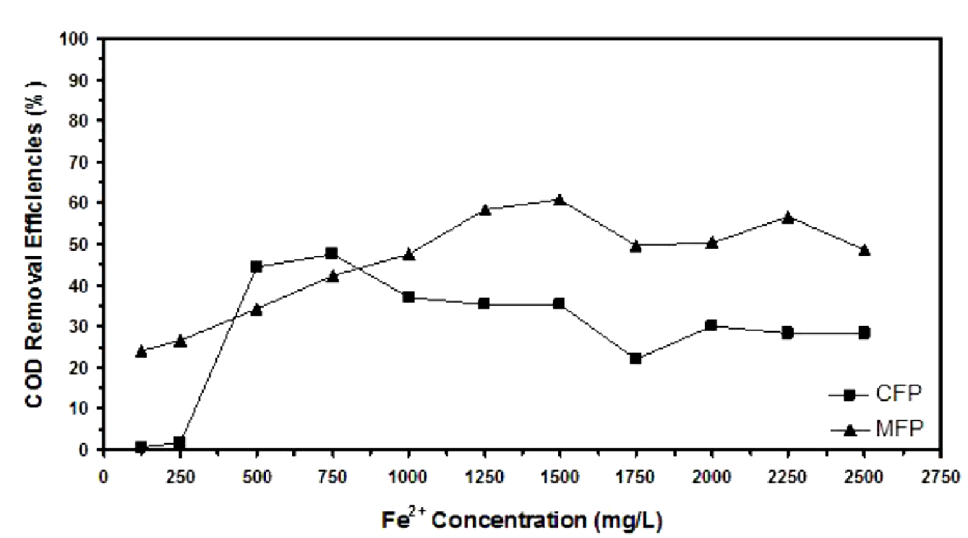
Figure 3. Figure with short caption (caption centred).

Tables
Tables should be centred unless they occupy the full width of the text. Tables should be numbered sequentially throughout the text and referred to in the text by number (table 1, not tab. 1 etc). Captions should be placed at the top of the table and should have a full stop (period) at the end. Except for very narrow tables with a wide caption (see examples below) the caption should be the same width as the table. Tables should have only horizontal rules and no vertical ones. Generally, only three rules should be used: one at the top of the table, one at the bottom, and one to separate the entries from the column headings. Table rules should be 0.5 points wide.

Table 6. A table with headings spanning two columns and containing notesª.
Nucleus | Thickness  (mg cm^{–2}) | Composition | Separation energies
 |  |  | , n (MeV) | , 2n (MeV)
¹⁸¹Ta | 19.3±0.1^{b} | Natural | 7.6 | 14.2
²⁰⁸Pb | 3.8±0.8^{c} | 99% enriched | 7.4 | 14.1
²⁰⁹Bi | 2.6±0.01^{c} | Natural | 7.5 | 14.4
ª Notes are referenced using alpha superscripts.
^{b} Self-supporting.
^{c} Deposited over Al backing.

Equations
Make sure that your Equation Editor or MathType fonts, including sizes, are set up to match the text of your document.
(1)

- Another section of your paper
The first paragraph after a heading is not indented (Bodytext style).
Other paragraphs are indented (BodytextIndented style).

A subsection
Some text.
    - A subsubsection. The paragraph text follows on from the subsubsection heading but should not be in italic.

References
- A reference
This reference has two entries but the second one is not numbered (it uses the ‘Reference (no number)’ style. Please use the Vancouver numerical system where references are numbered sequentially throughout the text. The numbers occur within square brackets, like this [2], and one number can be used to designate several references. The reference list gives the references in numerical, not alphabetical, order.
- Aderhold J, Davydov V Yu, Fedler F, Klausing H, Mistele D, Rotter T, Semchinova O, Stemmer J and Graul J 2001 J. Cryst. Growth 222 701 More references
- Another references

