- Please make sure all the chemical purchased/transferred to the other bottle adhere to CLASS Regulations 2013. For the container size of above 125 ml, the packaging shall be labelled legibly and indelibly containing the following information:
 | Information Required | Explanation
a. | Product identifier | RS-Lower Cost Leadfree No Clean Solder Fire
b. | Supplier identification | RS Components Ltd  Birchington Road  Corby Northants  NN17 9RS  +44 (0)845 850 9900  RCustomerServicesUK@rs-components.com
c. | Signal word | Warning
d. | Hazard statement | Skin Sens. 1: H317 - May cause an allergic skin reaction.
e. | Hazard pictogram | Choose the relevant pictogram based on your SDS  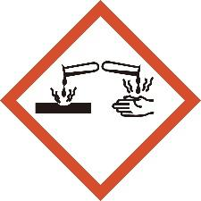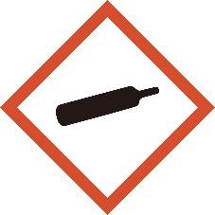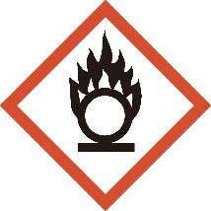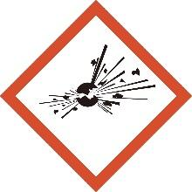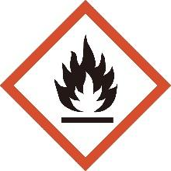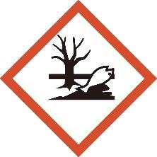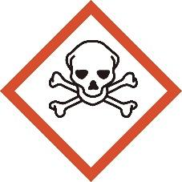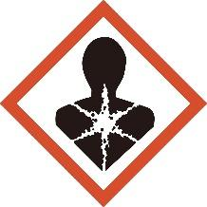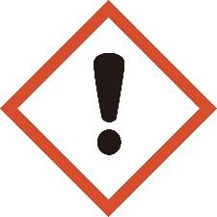
f. | Precautionary statement | Please refer your SDS

- For the container size of 125 ml and below, the packaging shall be labelled legibly and indelibly containing the following information:
 | Information Required | Explanation
a. | Product identifier | Name of chemical
b. | Supplier Identification | Detail of supplier
c. | Signal Word | Please refer your SDS
d. | Hazard pictogram | Choose the relevant pictogram based on your SDS
e. | Statement “Read Safety Data Sheet before use”. | Read Safety Data Sheet before use.  baca Helaian Data Keselamatan sebelum digunakan.

- For precise size and format of labeling, user may refer to Express Labeling Self-Assessment (ELSA) checklist by DOSH Malaysia. The figure below shows the template of chemical labeling which chemical user can use by replacing the information required according to the respective chemical used.

For container size of above 125 ml
ACETONE
ASETON

Manufacturer (Pengilang) :
Oil Company, 515 Touhy Avenue,
Des Plaines, IL 60018 USA.
(24 hr Emergency Tel. No: 800 424-9300)

Supplier (Pembekal) :
Syarikat Minyak Petrol Sdn. Bhd.
1126K Jalan Kg. Attap,
50534 Kuala Lumpur.
(Tel : 03-2731234, 800-1234567)

DANGER BAHAYA
HAZARD STATEMENTS
PERNYATAAN BAHAYA

Highly flammable liquid and vapor.
Cecair dan wap amat mudah terbakar.
Causes serious eye irritation.
Menyebabkan kerengsaan mata yang serius.
May cause drowsiness or dizziness.
Boleh menyebabkan mengantuk atau kepeningan.
PRECAUTIONARY STATEMENTS
PERNYATAAN BERJAGA-JAGA

Keep away from heat/sparks/open flames/hot surfaces. No smoking.
Jauhkan daripada haba/ percikan api/ nyalaan
terbuka/permukaan panas. Dilarang merokok.
Keep container tightly closed.
Pastikan bekas ditutup dengan ketat.
Avoid breathing mist or vapors.
Elakkan daripada tersedut kabus atau wap.
Wear protective gloves/eye protection/face protection.
Pakai sarung tangan pelindung/ perlindungan mata/ perlindungan muka.

For container size of below 125 ml
ACETONE
ASETON

READ SAFETY DATA SHEET BEFORE USE
BACA HELAIAN DATA KESELAMATAN SEBELUM DIGUNAKAN
Manufacturer : Oil Company, 515 Touhy Avenue,
(Pengilang) Des Plaines, IL 60018 USA.
(24 hr Emergency Tel. No: 800 424-9300)
Supplier : Syarikat Minyak Petrol Sdn. Bhd.
(Pembekal) 1126K Jalan Kg. Attap,
50534 Kuala Lumpur.
(Tel : 03-2731234, 800-1234567)
DANGER
BAHAYA

