**TITLE**

Author1,a,* Author2,a Author3,b Author4c

a Address 1

b Address 2

c Address 3

*Corresponding author: [*email@yahoo.com*](mailto:email@yahoo.com)

**EXTENDED ABSTRACT**

*The extended abstract should consist of* ***500-600 WORDS*** *(****MAXIMUM: 600 WORDS including figure/table caption and references)*** *in single paragraph (****Font: Arial, Size: 12, Line Spacing: Single****) and should state the research purpose, methodology, the principal findings, brief discussion and major conclusions. Figure and table are encouraged to include in the extended abstract, but they should be limited to* ***MAXIMUM TWO (2)*** *(either 2 figures/tables or 1 figure plus 1 table). References should be avoided in the extended abstract, but if essential, they must be cited in full. Only* ***MAXIMUM TWO (2)*** *pages are allowed for each extended abstract submitted based on this abstract template. The extended abstract should consist of* ***500-600 WORDS*** *(****MAXIMUM: 600 WORDS including figure/table caption and references)*** *in single paragraph (****Font: Arial, Size: 12, Line Spacing: Single****) and should state the research purpose, methodology, the principal findings, brief discussion and major conclusions. Figure and table are encouraged to include in the extended abstract, but they should be limited to* ***MAXIMUM TWO (2)*** *(either 2 figures/tables or 1 figure plus 1 table). References should be avoided in the extended abstract, but if essential, they must be cited in full. Only* ***MAXIMUM TWO (2)*** *pages are allowed for each extended abstract submitted based on this abstract template. The extended abstract should consist of* ***500-600 WORDS*** *(****MAXIMUM: 600 WORDS including figure/table caption and references)*** *in single paragraph (****Font: Arial, Size: 12, Line Spacing: Single****) and should state the research purpose, methodology, the principal findings, brief discussion and major conclusions. Figure and table are encouraged to include in the extended abstract, but they should be limited to* ***MAXIMUM TWO (2)*** *(either 2 figures/tables or 1 figure plus 1 table). References should be avoided in the extended abstract, but if essential, they must be cited in full. Only* ***MAXIMUM TWO (2)*** *pages are allowed for each extended abstract submitted based on this abstract template. The extended abstract should consist of* ***500-600 WORDS*** *(****MAXIMUM: 600 WORDS including figure/table caption and references)*** *in single paragraph (****Font: Arial, Size: 12, Line Spacing: Single****) and should state the research purpose, methodology, the principal findings, brief discussion and major conclusions. Figure and table are encouraged to include in the extended abstract, but they should be limited to* ***MAXIMUM TWO (2)*** *(either 2 figures/tables or 1 figure plus 1 table). References should be avoided in the extended abstract, but if essential, they must be cited in full. Only* ***MAXIMUM TWO (2)*** *pages are allowed for each extended abstract submitted based on this abstract template. The extended abstract should consist of* ***500-600 WORDS*** *(****MAXIMUM: 600 WORDS including figure/table caption and references)*** *in single paragraph (****Font: Arial, Size: 12, Line Spacing: Single****) and should state the research purpose, methodology, the principal findings, brief discussion and major conclusions. Figure and table are encouraged to include in the extended abstract, but they should be limited to* ***MAXIMUM TWO (2)*** *(either 2 figures/tables or 1 figure plus 1 table). References should be avoided in the extended abstract, but if essential, they must be cited in full. Only* ***MAXIMUM TWO (2)*** *pages are allowed for each extended abstract submitted based on this abstract template. The extended abstract should consist of* ***500-600 WORDS*** *(****MAXIMUM: 600 WORDS including figure/table caption and references)*** *in single paragraph (****Font: Arial, Size: 12, Line Spacing: Single****) and should state the research purpose, methodology, the principal findings, brief discussion and major conclusions. Figure and table are encouraged to include in the extended abstract, but they should be limited to* ***MAXIMUM TWO (2)*** *(either 2 figures/tables or 1 figure plus 1 table). References should be avoided in the extended abstract, but if essential, they must be cited in full. Only* ***MAXIMUM TWO (2)*** *pages are allowed for each extended abstract submitted based on this abstract template.*

Table 1. Properties of substrates with respect to pure water permeability, contact angle and −ΔGSL. ***(EXAMPLE)***

**

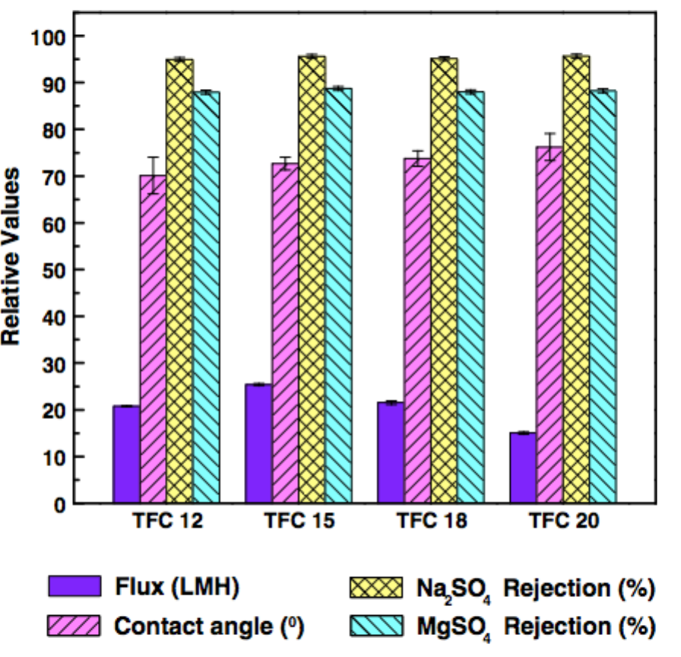

Figure 1. Water flux and salt separation rate of thin film composite nanofiltration membranes made of different substrates. ***(EXAMPLE)***

**Keywords**: *Please provide three-five (3-5) keywords that could be useful for information-retrieval purposes.*