Synthesis of Silver/Zeolite/LDH Nanocomposite

Siti Nabihan Ishakª, Nik Ahmad Nizam Nik Malek^{a,b}*, Mustaffa Shamsuddin^{c}, Juan Matmin^{c} and Gopinathan Sankar^{d}
ªDepartment of Biosciences, Faculty of Science, Universiti Teknologi Malaysia, 81310 UTM Skudai, Johor, Malaysia
^{b}Centre for Sustainable Nanomaterials (CSNano), Ibnu Sina Institute for Scientific and Industrial Research (ISI-ISIR), Universiti Teknologi Malaysia, 81310 UTM Skudai, Johor, Malaysia
^{c}Department of Chemistry, Faculty of Science, Universiti Teknologi Malaysia, 81310 UTM Skudai, Johor, Malaysia
^{d}Department of Chemistry, Materials Chemistry Section, University College London, United Kingdom
*Corresponding author: niknizam@utm.my

Abstract
This research was aimed to synthesize and characterize a silver-zeolite/layered double hydroxide (LDH) nanocomposite as a versatile adsorbent. The synthesized zeolite A, silver-loaded zeolite (Ag-Zeo), LDH, Zeo-LDH and AgZeo-LDH were characterized using X-ray diffraction (XRD), field emission scanning electron microscopy (FESEM) and energy dispersive X-ray (EDX), confirming the formation of silver-zeolite/LDH nanocomposite (AgZeo-LDH) where the LDH nanoparticles formed on the Ag-Zeo surfaces.
Keywords: Silver; zeolite; layered double hydroxide; nanocomposite

Introduction
In recent years, one of the proposed approaches to treat contaminants in the water is by using zeolite and layered double hydroxide (LDH) as adsorbents. For example, Bezerra et al. (2019) managed to remove cationic and anionic compounds in petroleum production waste by coating zeolite with LDH. Recently, the zeolite-LDH composite provides greater efficiency to remove toxic compounds such as cadmium (Zhang et al., 2020) and reactive orange six (Belsivo et al., 2020). Furthermore, other studies have shown that zeolite can enhance silver release under a long period to effectively inhibit bacterial growth (Qing et al., 2020). Despite the superior qualities of zeolite, LDH, and Ag, there are no studies that synthesize zeolite, LDH and silver in a single composite. Therefore, this research aims to create a nanocomposite of silver-loaded zeolite with LDH (AgZeo-LDH). This nanocomposite is expected to be have different capabilities eliminating pollutants in the water media: zeolite has high cation exchange capacity (Indarto et al., 2019), LDH has anion exchange capacity (Matusik and Rybka, 2019) and silver has powerful antibacterial activity (Sadoon et al., 2020). Thus, by combining these three materials, the nanocomposite could be used as an economical clean up agent of polluted waters.

Materials and methods
The synthesis of zeolite A and Ag-modified zeolite has been reported previously (Ishak et al., 2020). Initially, 1.0 g Ag-Zeo was added with 50 mL of 0.3 M Mg(NO₃)₂ and 50 mL of 0.1 M Al(NO₃)₃ in a Teflon bottle. The mixture was stirred at 80°C for 4 h. The pH was maintained at pH 11 by adding 1.0 M Na₂CO₃ and 1.0 M NaOH. Finally, the resulting solid was washed with distilled water and dried at 60°C in an oven overnight. A similar technique was applied in preparing Zeo-LDH using raw zeolite A. The synthesis of Mg/Al LDH was carried out following the co-precipitation method in which Mg(NO₃)₂ and Al(NO₃)₃ were dissolved in 200 mL of distilled water in the ratio of 3:1 (Mg:Al). The pH was then adjusted to pH 11 using 1M NaOH and 1 M Na₂CO₃. After that, the mixture underwent hydrothermal treatment at 150°C for 24 h. The generated Mg/Al LDH (LDH) was washed using distilled water and dried at 60°C in an oven overnight.

Each sample was characterized using X-ray diffraction method on a Bruker AXS GmbH (German) diffractometer. Field emission scanning electron microscopy (FESEM) (Hitachi SU8020) analysis was conducted to examine the morphology and energy dispersive X-ray (EDX) for elemental analysis of the samples.

Results and discussion
Figure 1 shows X-ray diffractogram of the synthesized zeolite A, Ag-Zeo, LDH, Zeo-LDH, and AgZeo-LDH. The diffractogram of zeolite A presented sharp and narrow peaks belonging to a simple cubic crystalline system (Iqbal et al., 2019; Wang et al., 2020). Despite the presence of Ag⁺ as confirmed using the EDX analysis (Table 1), the unaltered diffractogram suggested that the crystalline structure did not change after Ag⁺ loading (Salim et al., 2016). The loading of Ag⁺ in the zeolite was indicated by FESEM images (Figure 2). After the loading, the smooth surfaces of zeolite A were covered by very fine particles, presumably Ag⁺.
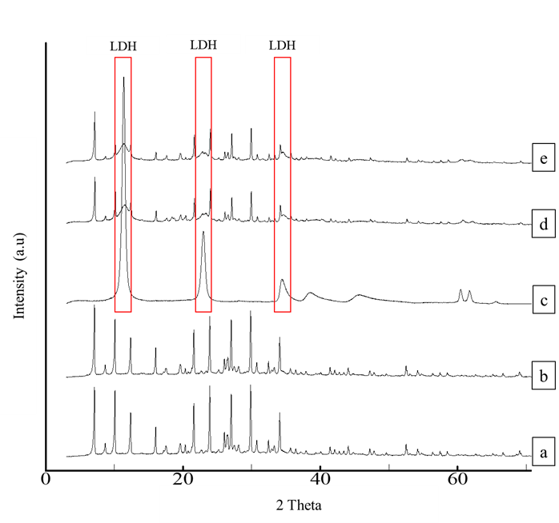
Figure 1 X-ray diffraction pattern of synthesized (a) zeolite A, (b) Ag-Zeo, (c) LDH, (d) Zeo-LDH and (e) AgZeo-LDH.

Referring to Figure 1, the diffractograms of Zeo-LDH and AgZeo-LDH showed that the samples contained LDH and zeolite A as proven by the broad and intense peaks of LDH phase at 2θ= 11.32°, 22.92°, and 34.28°, together with sharp and narrow peaks of zeolite A (Silva et al., 2018; Bezerra et al., 2019; Belsivo et al., 2020). LDH was observed as a nano-sized (130 nm) homogenous layer (Figure 2C). For its composite counterparts, FESEM images showed that the edges of the cubic crystal of Zeo-LDH (Figure 2D) were more defined compared to AgZeo-LDH (Figure 2E). Consequently, in the presence of Ag⁺, the morphology of the composite was slightly altered without a defined format, but they were totally covered with LDH crystals. The comparison of AgZeo-LDH and Zeo-LDH could be observed clearly in EDX data (Table 1) in which the presence of Ag⁺ was detected in AgZeo-LDH but not in Zeo-LDH, confirming the formation of the nanocomposite.

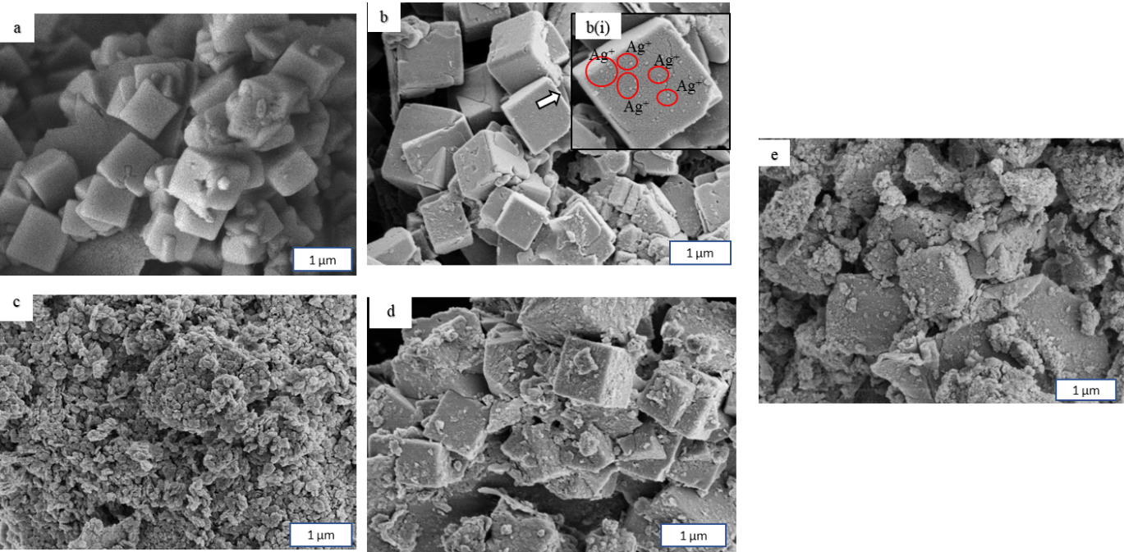
Figure 2 FESEM images of (a) Zeolite A, (b) Ag-Zeo (c) LDH, (d) Zeo-LDH and (e) AgZeo-LDH

Table 1: Elemental analysis of the samples from EDX
Elements | Ag-zeo | LDH | Zeo-LDH | AgZeo-LDH
Si | 14.0 ± 1.44 | 0.0 ± 0.0 | 9.6 ± 1.75 | 6.6 ± 1.66
Al | 13.2 ± 0.85 | 8.4 ± 3.12 | 11.2 ± 3.39 | 9.6 ± 1.85
Na | 9.7 ± 1.21 | 0.0 ± 0.0 | 6.8 ± 2.29 | 3.2 ± 1.57
Mg | 0.0 ± 0.0 | 20.8 ± 6.7 | 2.5 ± 2.24 | 9.7 ± 1.46
O | 44.3 ±2.62 | 55.6 ± 2.20 | 47.1 ± 7.71 | 50.9 ± 8.77
C | 16.0 ± 4.48 | 15.2 ± 11.72 | 22.7 ± 16.95 | 17.7 ± 14.54
S | 0.2 ± 0.06 | 0.0 ± 0.0 | 0.2 ± 0.06 | 0.3 ± 0.0
Ag | 2.4 ± 1.07 | 0.0 ± 0.0 | 0.0 ± 0.0 | 1.9 ± 0.25

In the nanocomposite formation, the desilication of Ag-Zeo in a strong alkaline condition during the nanocomposite formation might produce spaces to be filled with Al from the Al(NO₃) sources. The metastable state of Al centre in Ag-Zeo provided an active site for the growth of nanocrystal LDH (Li et al., 2018). In addition to that, Yamada et al. (2006) reported that the assembly of Mg²⁺ and Al³⁺ to form LDH was contributed by a high cation-exchange capacity of zeolite A. The discharge of Na from Ag-Zeo allowed Mg²⁺ from Mg(NO₃)₂ to refill it, forcing the growth of LDH on the surface of cubic crystal Ag-Zeo to produce the nanocomposite AgZeo-LDH.

Conclusion
The AgZeo-LDH nanocomposite has been successfully created through the addition of AgZeo during the synthesis of Mg/Al LDH as confirmed by XRD, FESEM and EDX.

Acknowledgement
This project is funded under Kurita Water and Environment Foundation (KWEF) research project (Vot No: 4B410) and UTMShine (Flagship) scheme (Vot No: 03G81).

References
Bezerra, B., Bieseki, L., da Silva, D., & Pergher, S. (2019). Development of a zeolite A/LDH composite for simultaneous cation and anion removal. Materials, 12(4), 661.
Indarto, A., Putra, I. A., Riyano, Noersalim, S., Hartanto, Y., & Handojo, L. (2019). Zeolites as adsorbent materials for decolorization of crude terpineol. IOP Conference Series: Materials Science and Engineering, 599, 012021.
Iqbal, A., Sattar, H., Haider, R., & Munir, S. (2019). Synthesis and characterization of pure phase zeolite 4A from coal fly ash. Journal of Cleaner Production, 219, 258-267.
Ishak, S. N., Malek, N. A. N. N., Yusop, Z., Williams, C. D., Suhartono, S., & Syafiuddin, A. (2020). Evaluation of phase transformation behaviors of zeolite and antibacterial properties against Gram‐positive and ‐negative bacteria. Journal Chinese Chemical Society, In press.
Li, R., Xue, T., Bingre, R., Gao, Y., Louis, B., & Wang, Q. (2018). Microporous Zeolite@ Vertically Aligned Mg–Al layered double hydroxide core@ shell structures with improved hydrophobicity and toluene adsorption capacity under wet conditions. ACS Applied Materials & Interfaces, 10(41), 34834-34839.
Matusik, J., & Rybka, K. (2019). Removal of chromates and sulphates by Mg/Fe LDH and heterostructured LDH/halloysite materials: Efficiency, selectivity, and stability of adsorbents in single-and multi-element systems. Materials, 12(9), 1373.
Qing, Y., Li, K., Li, D., & Qin, Y. (2020). Antibacterial effects of silver incorporated zeolite coatings on 3D printed porous stainless steels. Materials Science and Engineering: C, 108.
Sadoon, A. A., Khadka, P., Freeland, J., Gundampati, R. K., Manso, R. H., Ruiz, M. (2020). Silver ions caused faster diffusive dynamics of histone-like Nucleoid-Structuring Proteins in Live Bacteria. Applied and Environmental Microbiology, 2020; 86 (6)
Salim, M. M., & Malek, N. A. N. N. (2016). Characterization and antibacterial activity of silver exchanged regenerated NaY zeolite from surfactant-modified NaY zeolite. Materials Science and Engineering: C, 59, 70–77.
Silva, L. N. D., Moraes, D. dos S., Santos, S. C. A., & Corrêa, J. A. M. (2018). Joint synthesis of zeolite A-LDH from mineral industry waste. Applied Clay Science, 161, 163–168
Wang, P., Sun, Q., Zhang, Y., & Cao, J. (2019). Synthesis of zeolite 4A from kaolin and its adsorption equilibrium of carbon dioxide. Materials, 12(9), 1536
Zhang, X., Xue, Y., Gao, J., He, C., Ji, Y. and Dou. Y. (2020). Comparison of adsorption mechanisms for cadmium removal by modiﬁed zeolites and sands coated with Zn-layered double hydroxides. Chemical Engineering, 380, 122578.

