GUIDELINE ON UTMFIN-RADIS ONLINE CLAIM & PAYMENT APPLICATION
PROJECT LEADER APPLICATION / CLAIMS

- Download & Read Bursary Circular No 2.2015 (Bahasa Malaysia) by click here.

- Arranging and paste all billing, small receipts and invoices on A4 paper as below :
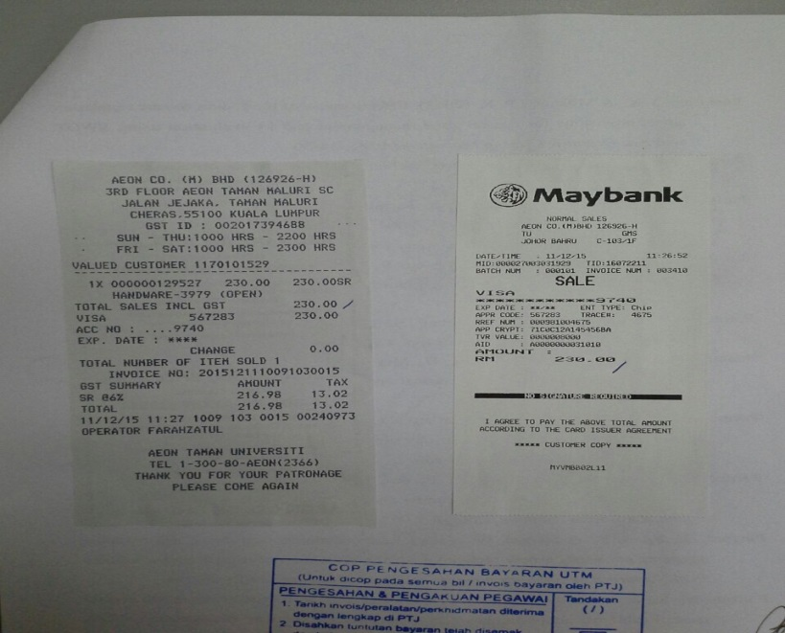

- Stamping and verify by signing the hardcopy documents as below :
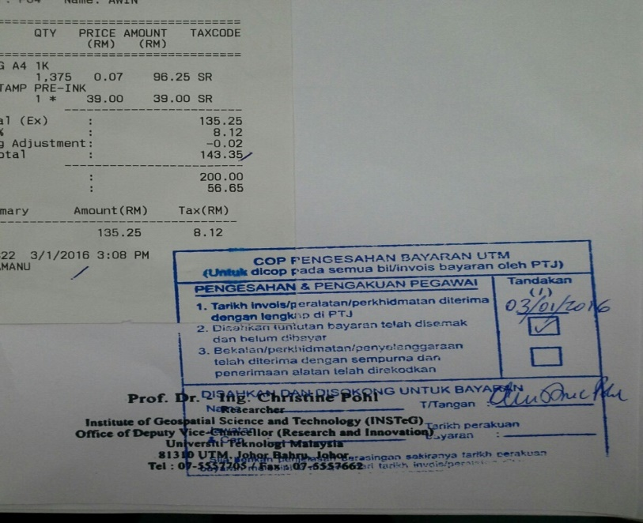

- Scanning the documents above as digital documents in PDF format only. For the purpose of merging several PDF documents, web application http://smallpdf.com/merge-pdf can be used as below :

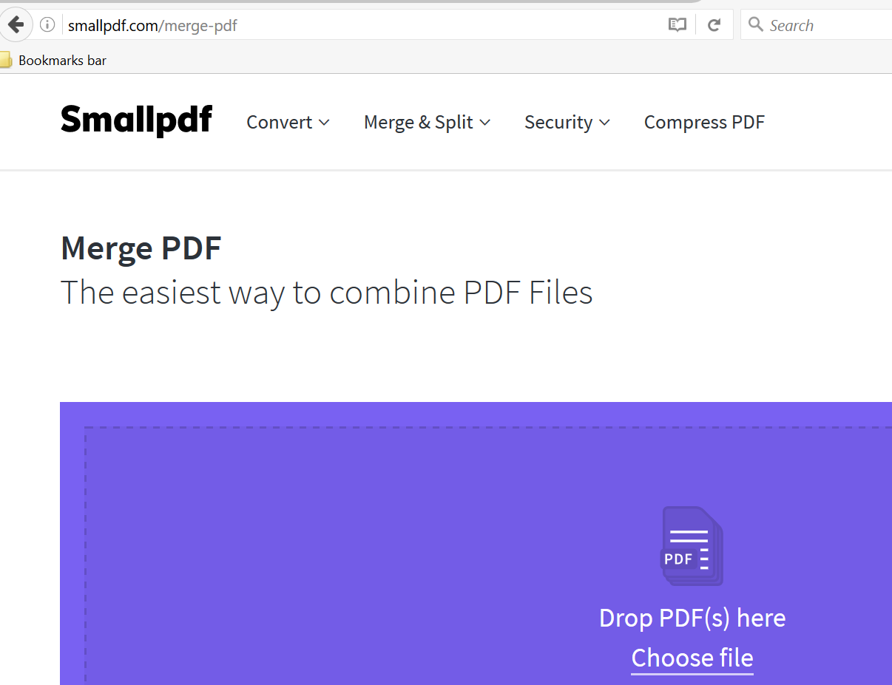

- For original document received from supplier or company such as invoices, receipts, cash bill, Discount Note, Debit Note, or Credit Note which doesn’t any colour element, the document must be stamped “CERTIFIED TRUE COPY” using the red ink before the document being scanned. Kindly refer to Clause 5.3 Bursary Circular No.2.2015 or example as shown below :
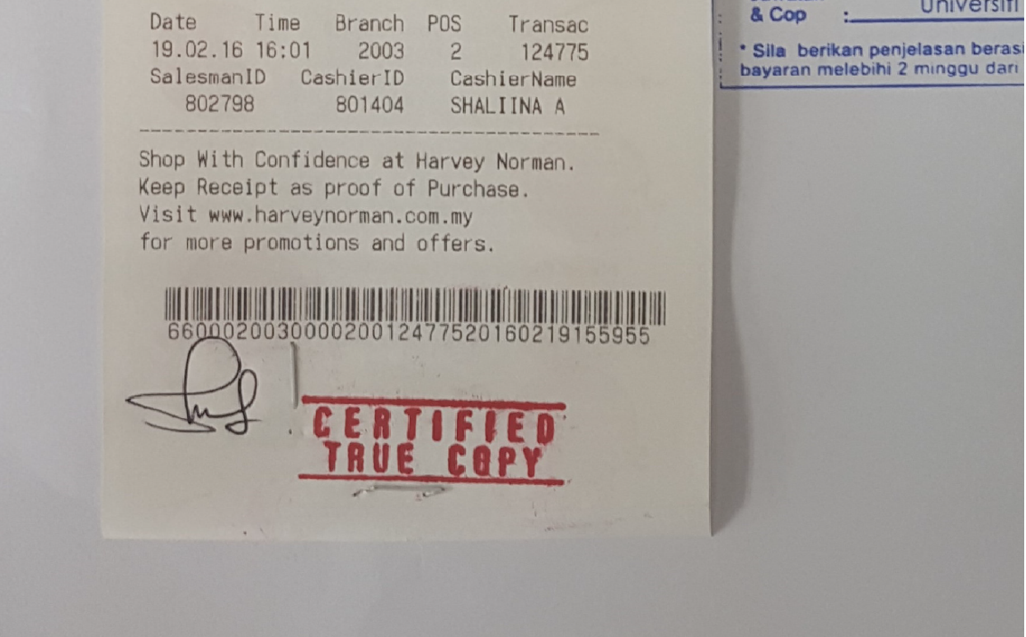

- Fill in the claims or payment information by login into UTMFin system via https://utmfin.utm.my.
User Id: Exactly same as HR System
Password: Staff ID / whichever being setup

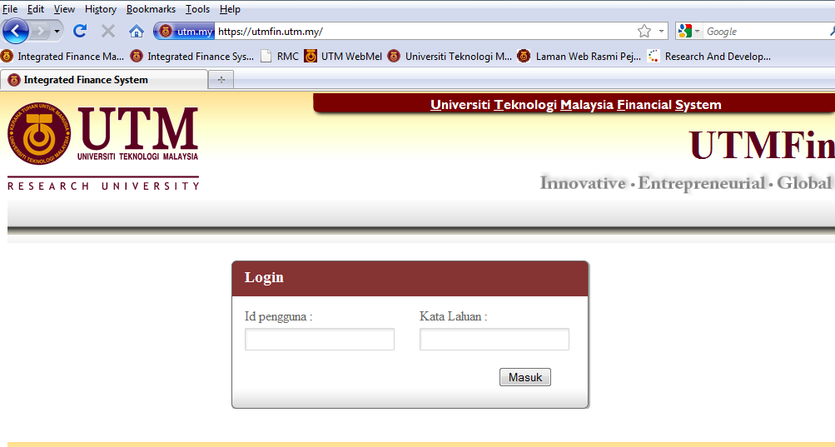
- Chosing the e-form in UTMFin System according the type of claim which related as below :

- Invoice Payment Application : Bayaran – Invois Bil

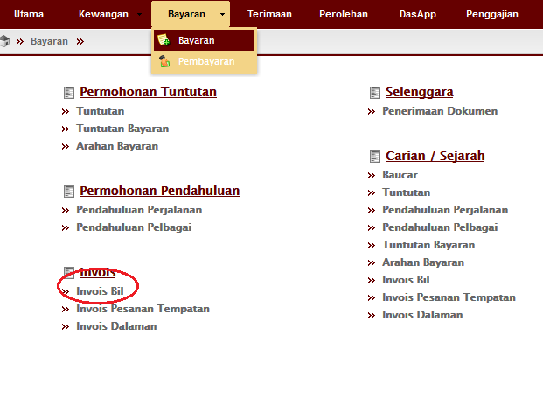

- Local Order Payment Application : Bayaran – Invois Pesanan Tempatan
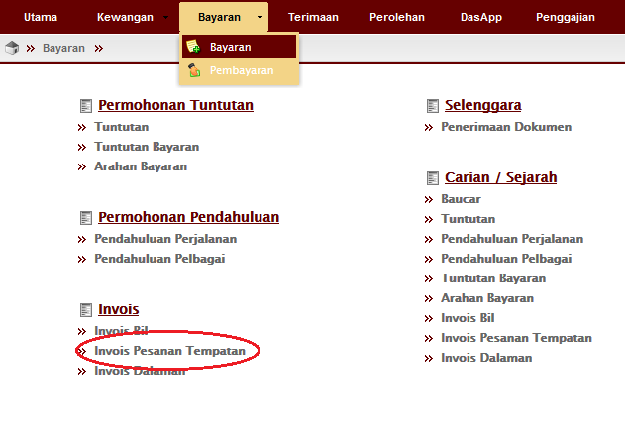

- Internal Invoice Payment Application (Vote Transfer) : Bayaran – Invois Dalaman
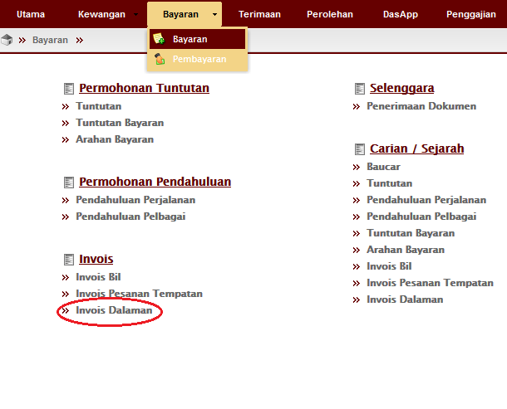

- Advance Travel Application : Bayaran – Pendahuluan Perjalanan
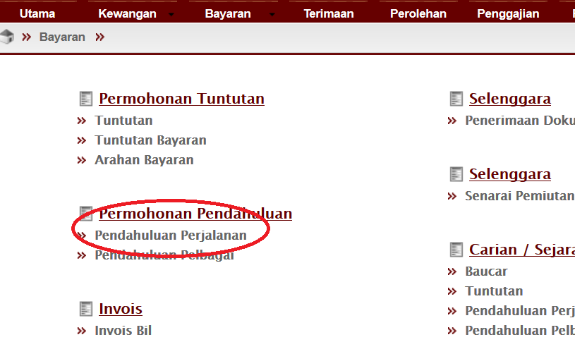

- Misellaneous Advance Application : Bayaran – Pendahuluan Pelbagai
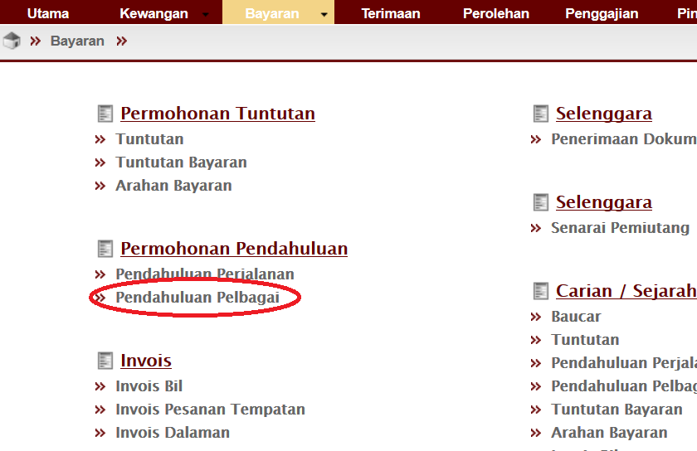

- Travel Claim Application : Bayaran – Tuntutan - (Tuntutan Dalam Negara & Tuntutan Luar Negara)
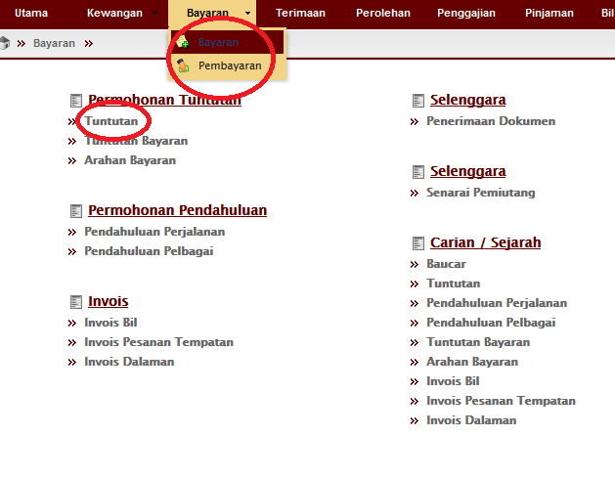

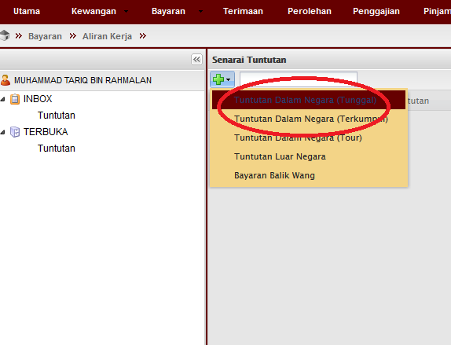

- Research Expert Payment Application : Bayaran Tuntutan Bayaran – (Jenis Upah Pakar Penyelidikan)

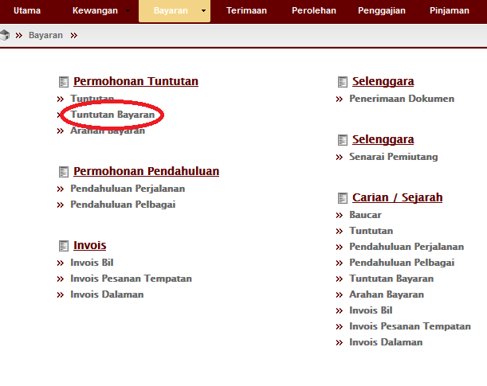

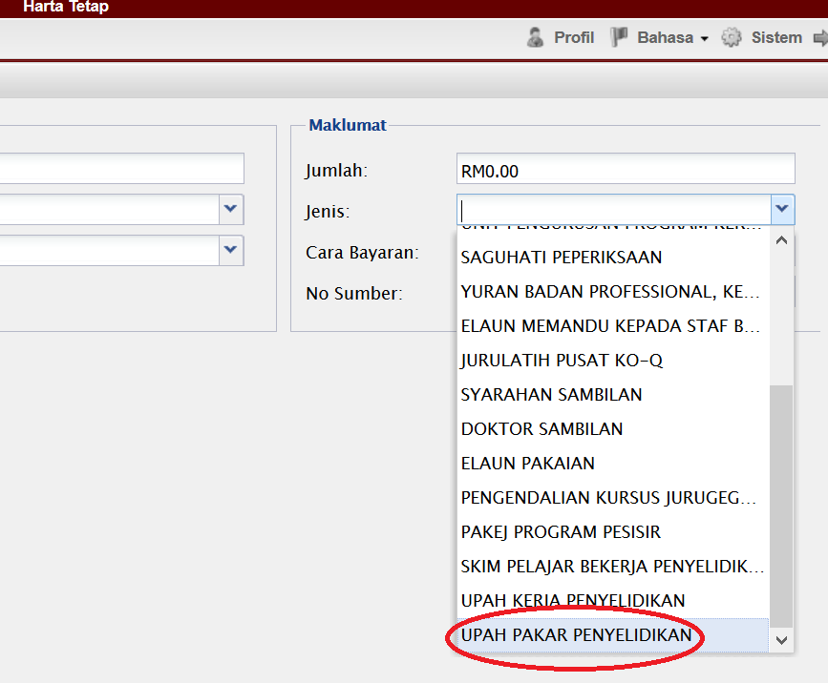

- Research Wages Payment Application : Tuntutan Bayaran – (Jenis Upah Kerja Penyelidikan)

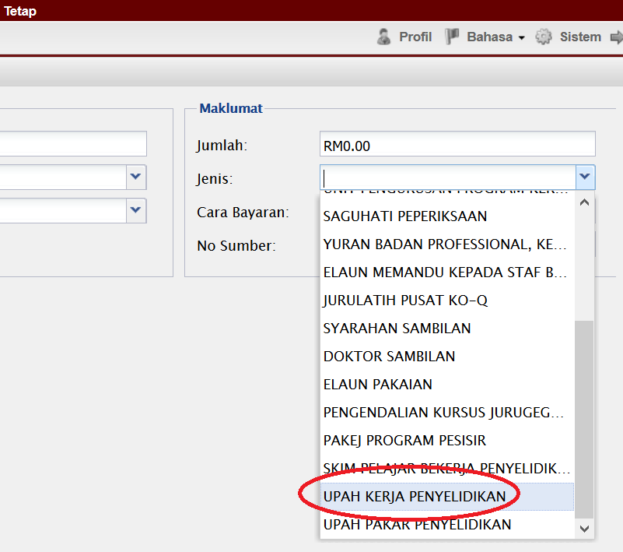

- Research Student Working Scheme Application : Tuntutan Bayaran – (Jenis Skim Pelajar Bekerja Penyelidikan)

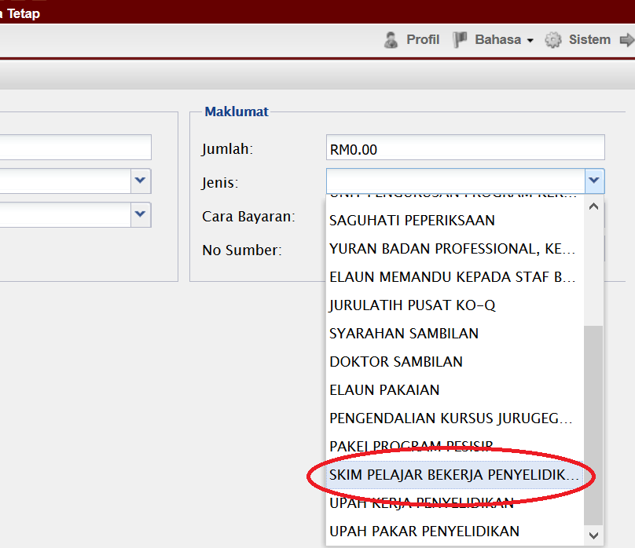

- Reimbursement Payment Application : Bayaran – Tuntutan - Bayaran Balik Wang

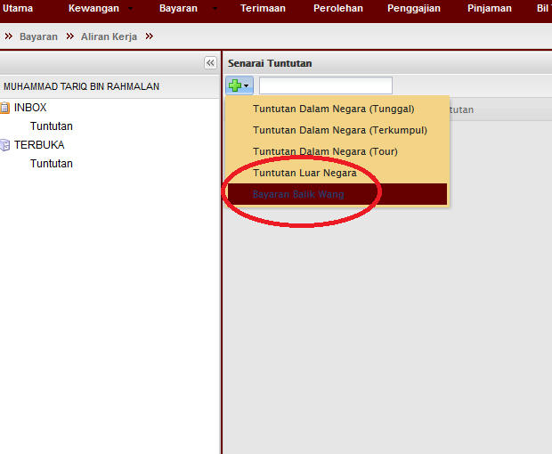

- Overtime Claims Application : Bayaran - Tuntutan Bayaran – (Jenis Lamparan Kerja)

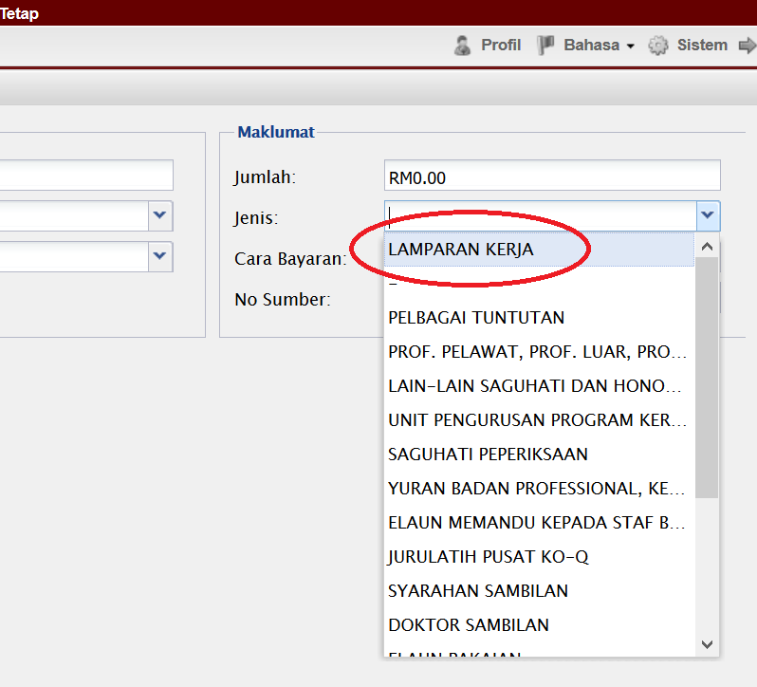

- Other Honorarium Payment Application : Bayaran - Tuntutan Bayaran – (Jenis Lain – lain Saguhati & Honorarium)

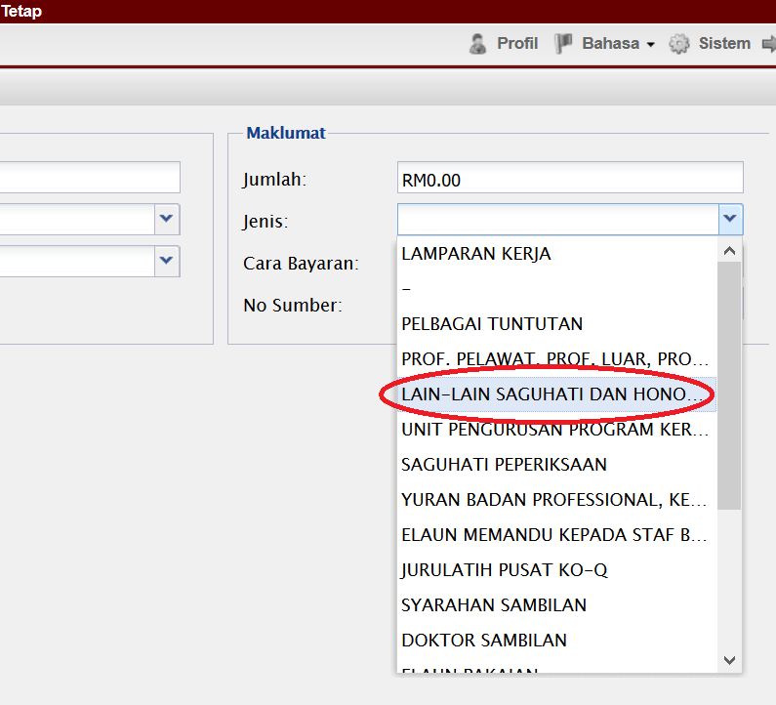

- Visiting Professor / Reseachers Honorium Payment Application : Bayaran - Tuntutan Bayaran – (Jenis Prof. Pelawat. Prof. Luar. Prof. Tamu)

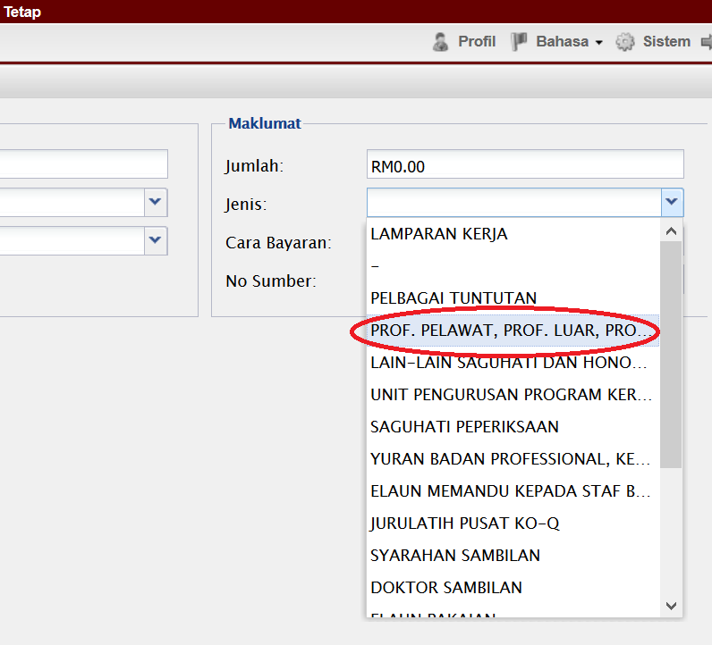

- Filled in all field applicable in UTMFin system and ensure all process such apply (Mohon), Register (Daftar) and Verify (Sah) were complete by clicking all related buttons.

- Application process will be completed by clicking the button Mohon (Apply) or Hantar (Send) as shown below :
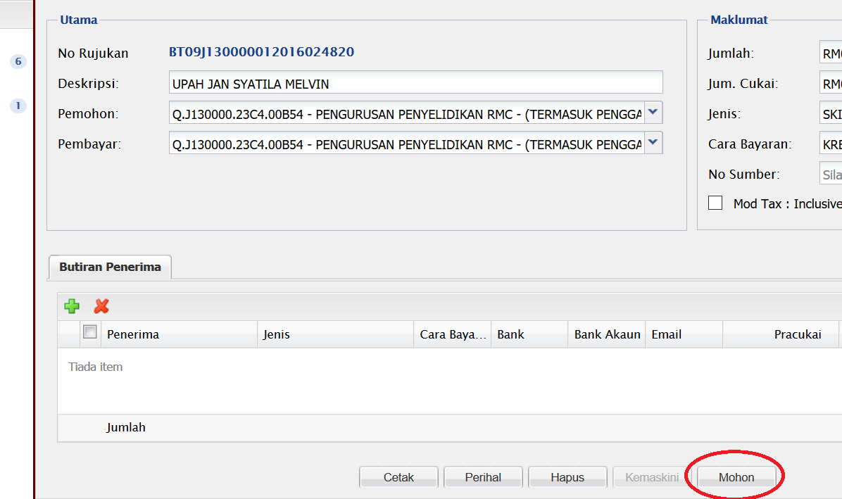

OR

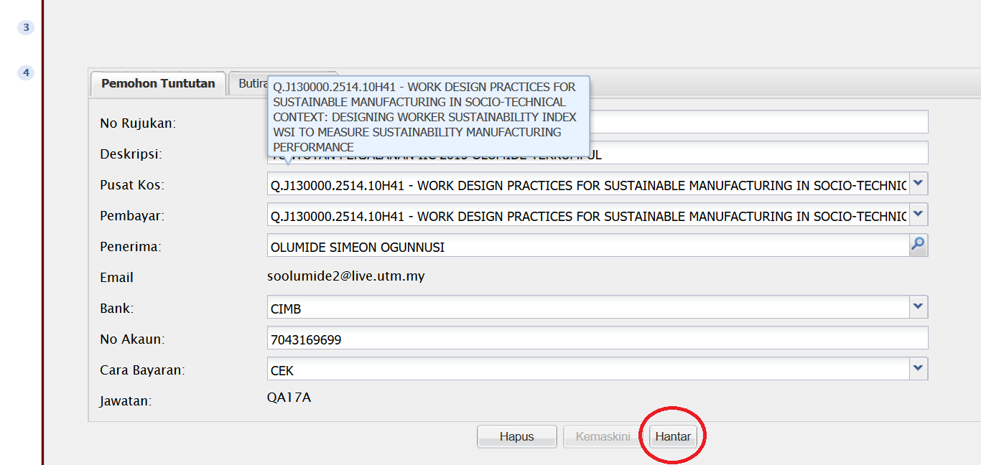

- Registration process must be completed by filled in Item Code and by clicking Daftar button.
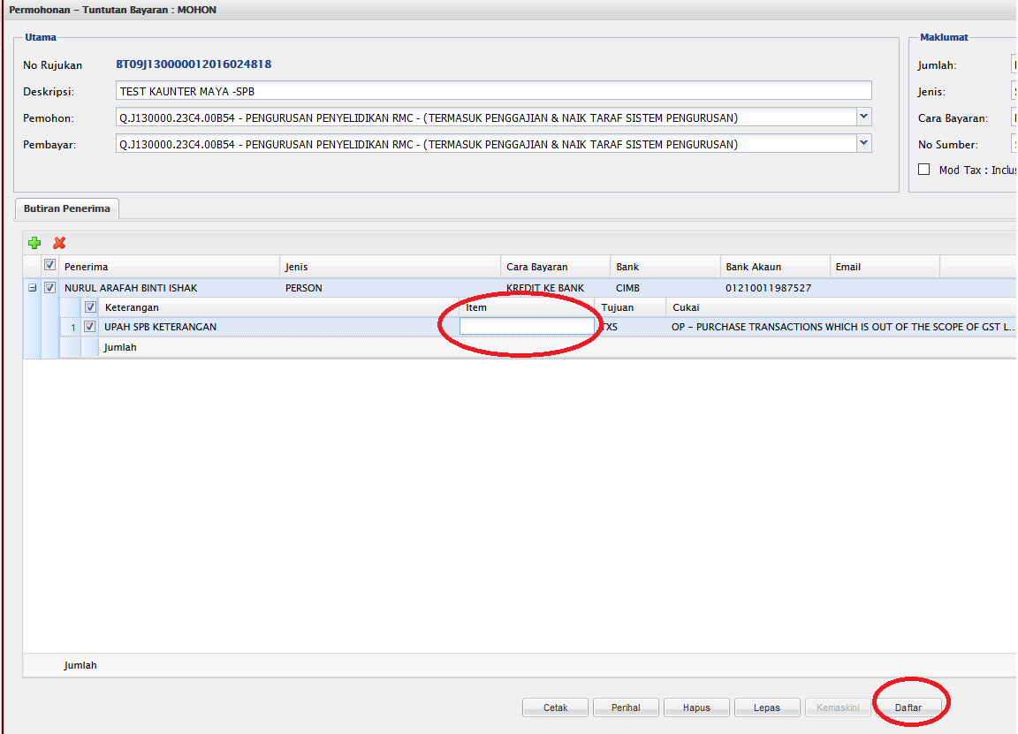

- Verification process can be completed by clicking Sah button.

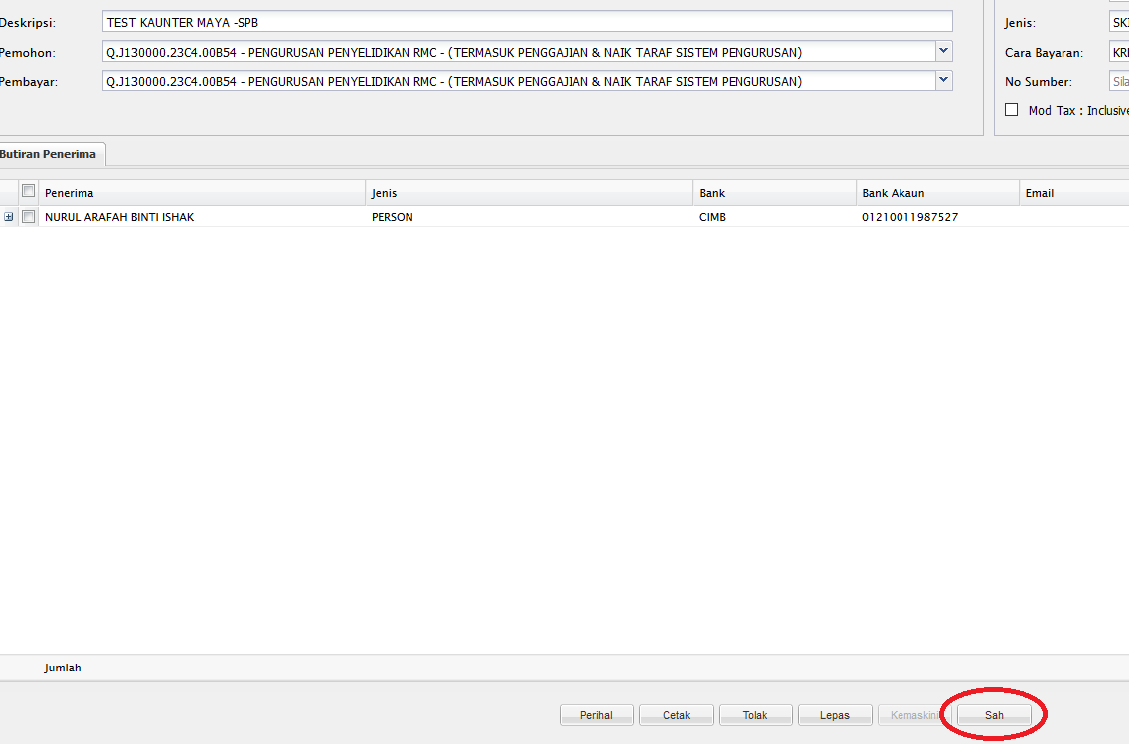

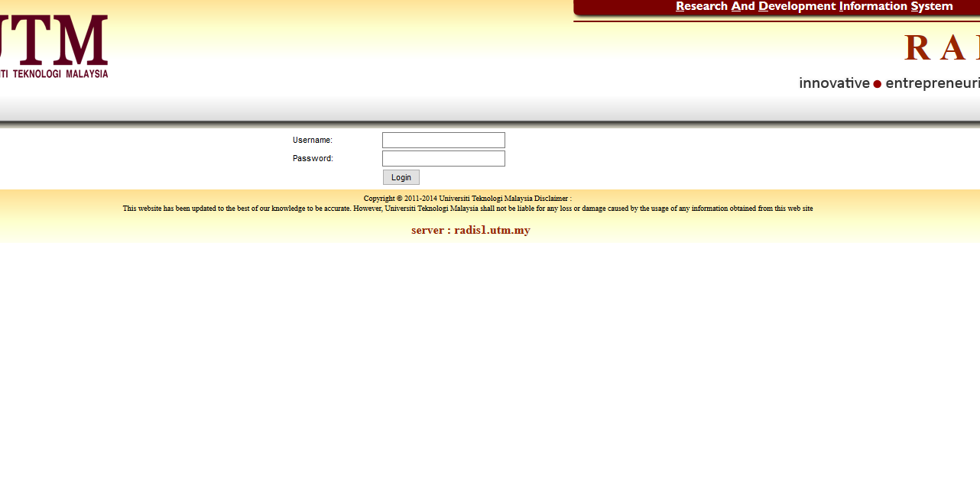
- Login into RADIS System for the purpose of uploading digital documents.

- Click on Research Grant menu for listing the related research cost center.

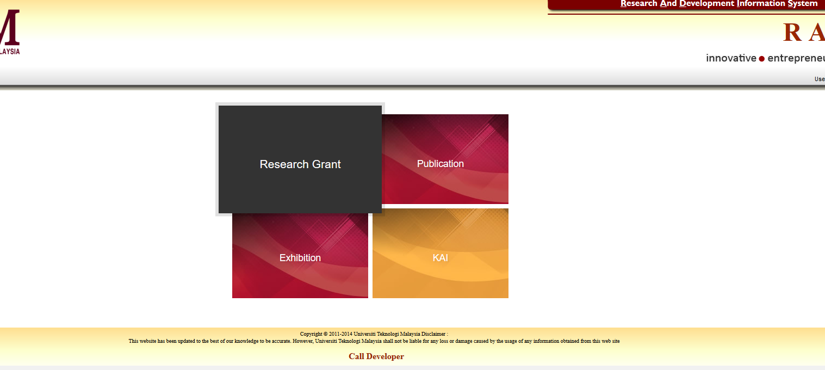
- Select research cost center which previously claimed in UTMFin system under role of Principle Investigator.
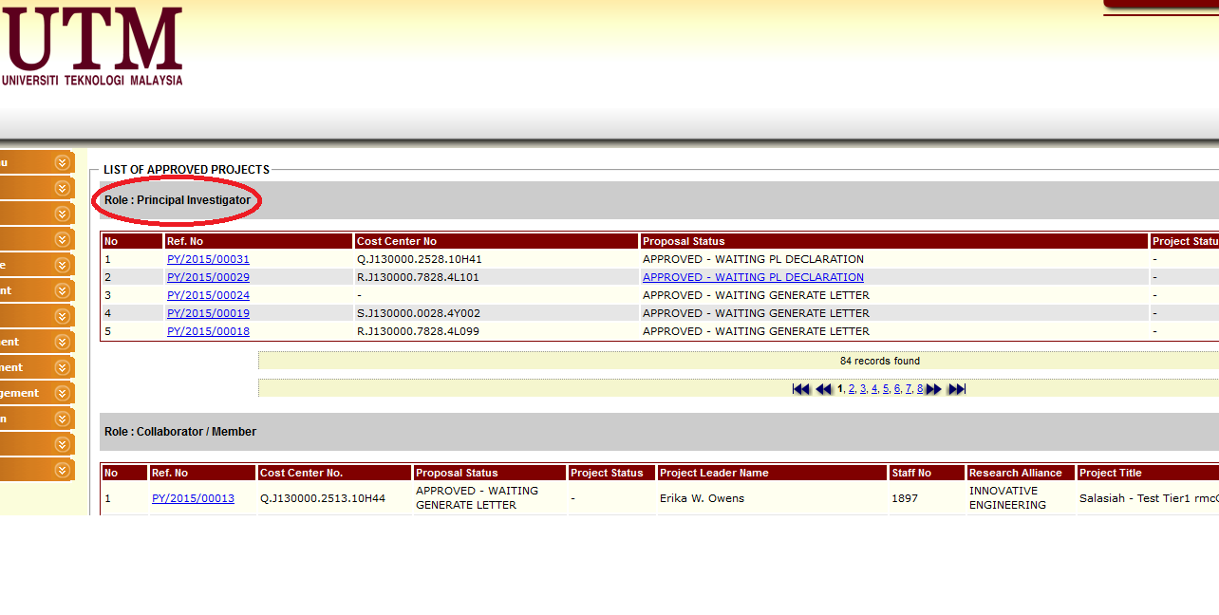
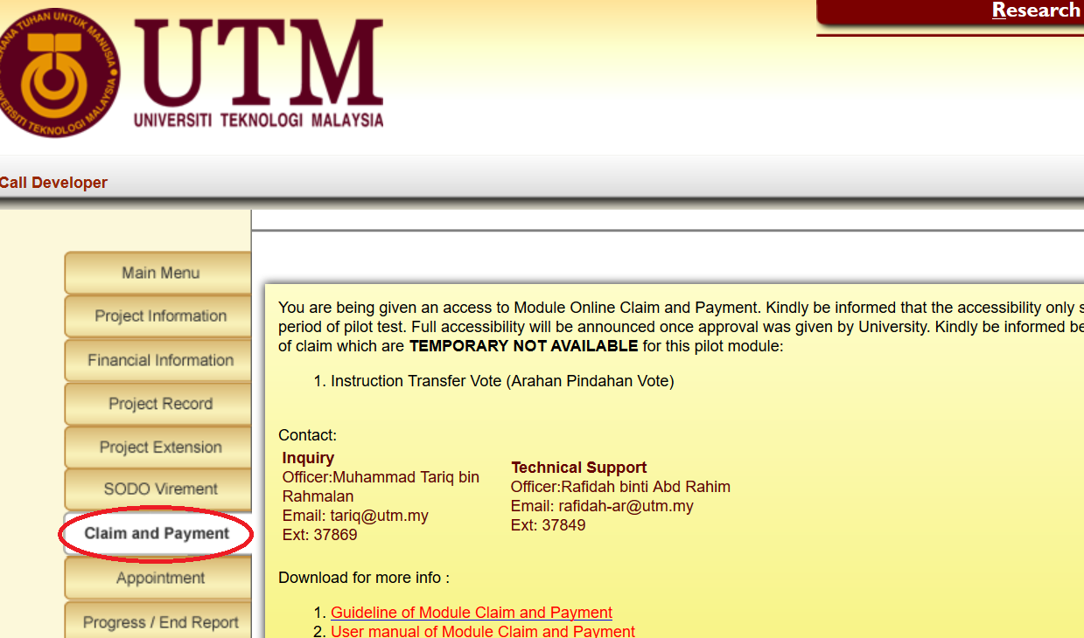
- Click Claim & Payment menu on list left side of the screen as shown below :

- Click on New button for the purpose of uploading digital documents for new submission application.
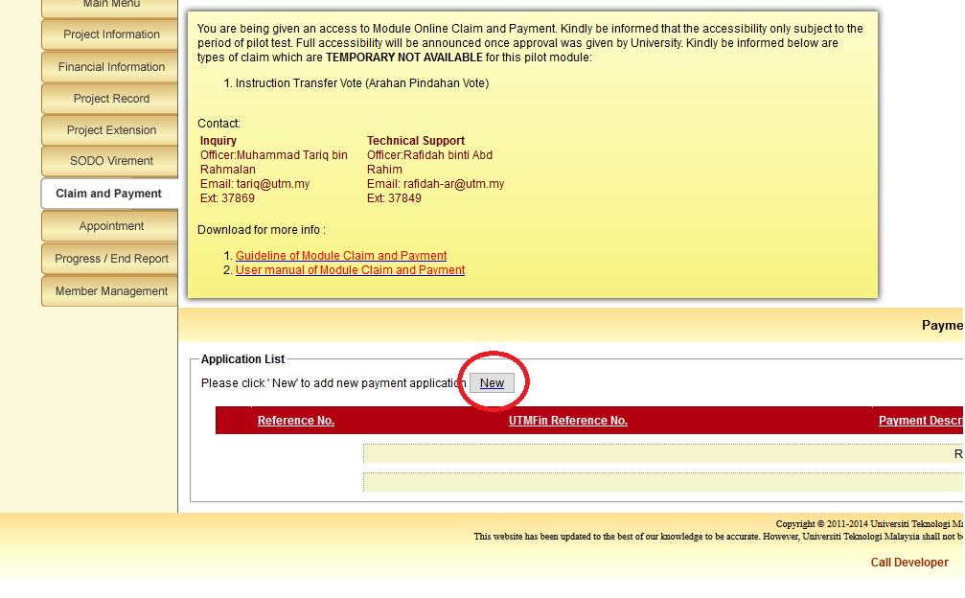

- Choose and select your application according to the claim description typed in UTMFin System by clicking droplist Payment For as shown below :

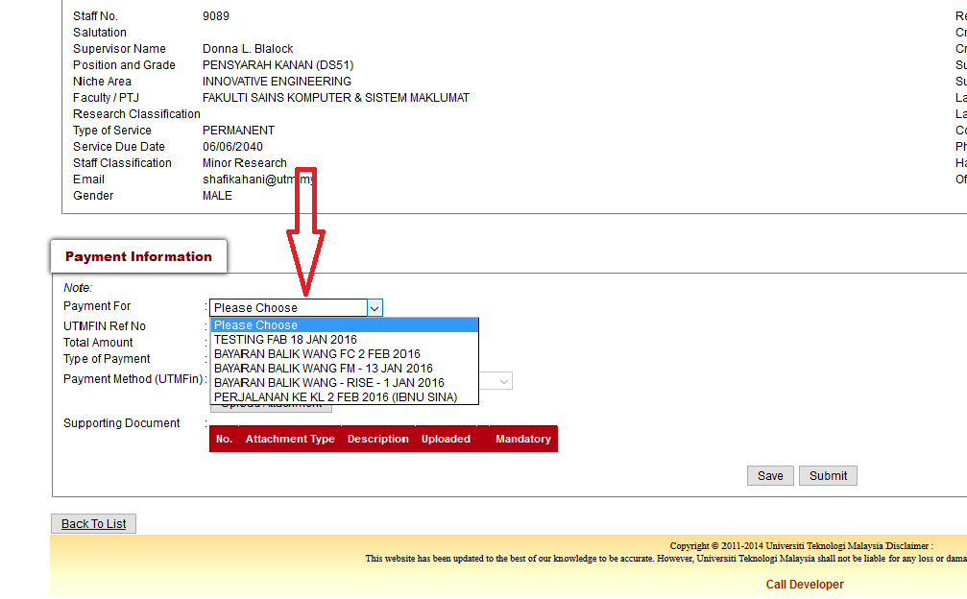
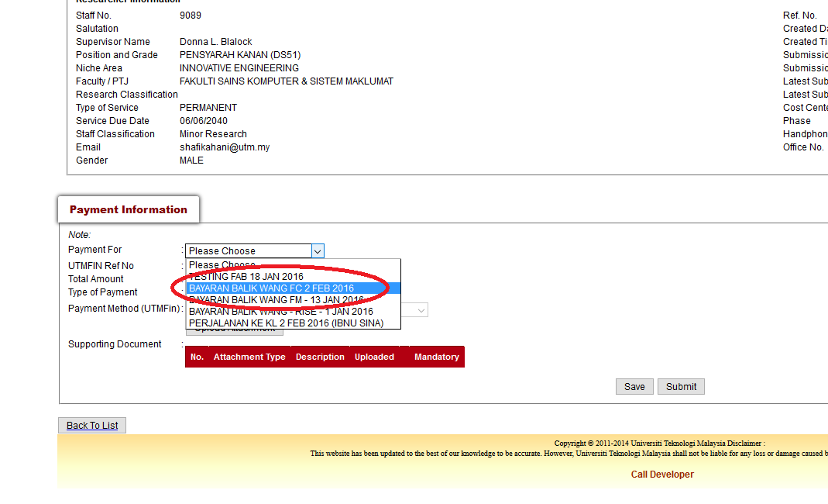
- Click the relevant claims application.
- Please click the relevant checkbox. The checkbox will appear according to type of claim. Please ensure that checkbox for Asset, Inventory or Maintenance will be clicked if there are related transactions in the claims application.

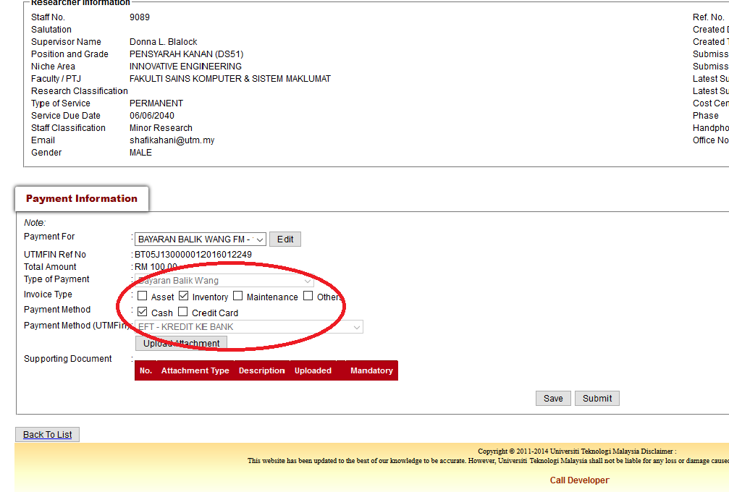

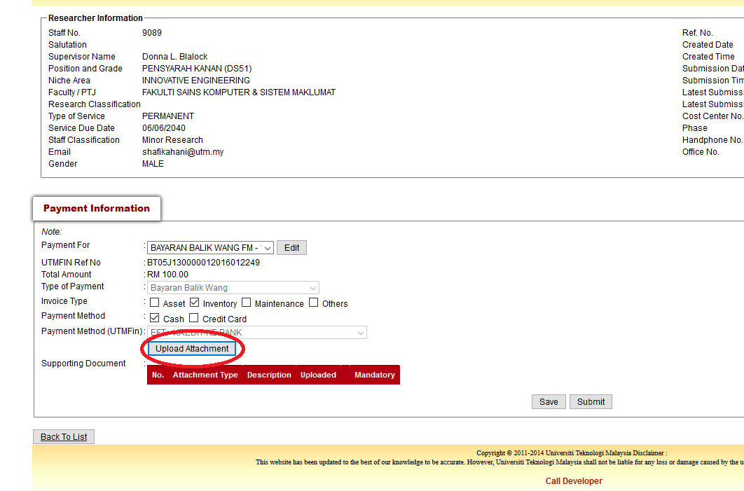
- Click Upload Attachment button in order for RADIS to generate relevant checklist and items according to type of claim.

- Kindly click Browse button to choose the related digital document according to Attachment Type and click Upload to start uploading the document. Kindly noted that the item which Mandatory field stated “Yes” were compulsory to be uploaded and make sure all digital documents uploaded accordingly.

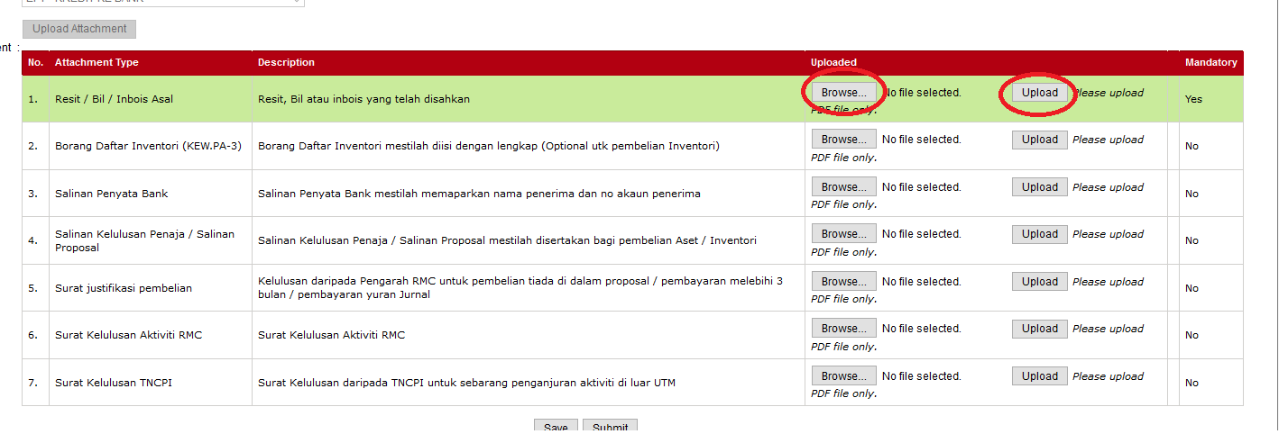

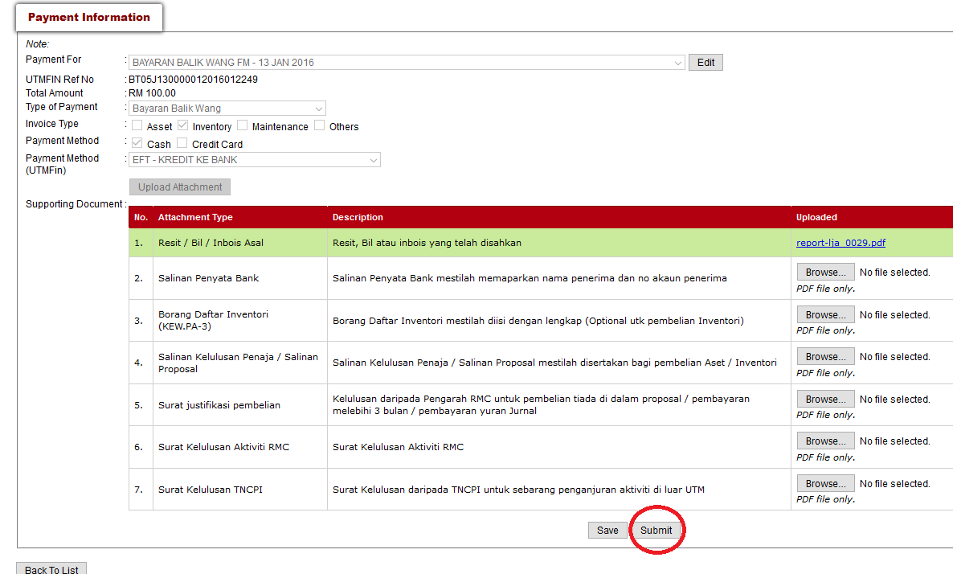
- Once all digital documents were uploaded accordingly, please click Submit button as shown below.

- Keep the original document into the formatted Document File. Project Leader may refer to RMC portal to download the guideline on how to prepare the Document File or order from Account & Asset Record Unit, Finance Department and instruct the vote transfer for the payment.

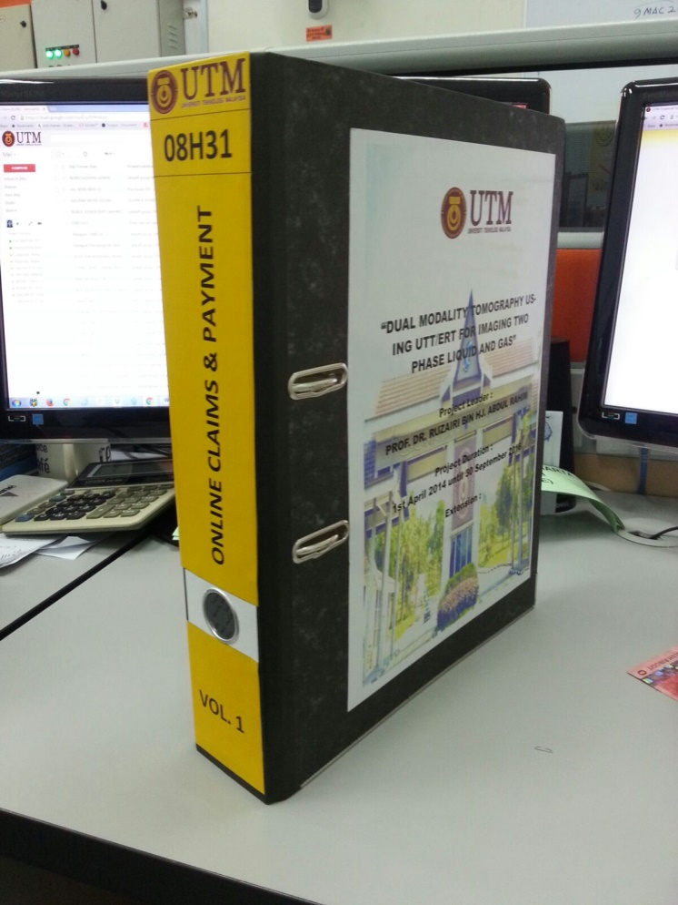

- Kindly make sure the original documents (hardcopy) were kept according to the type of claim in order to assist auditing process and future references.

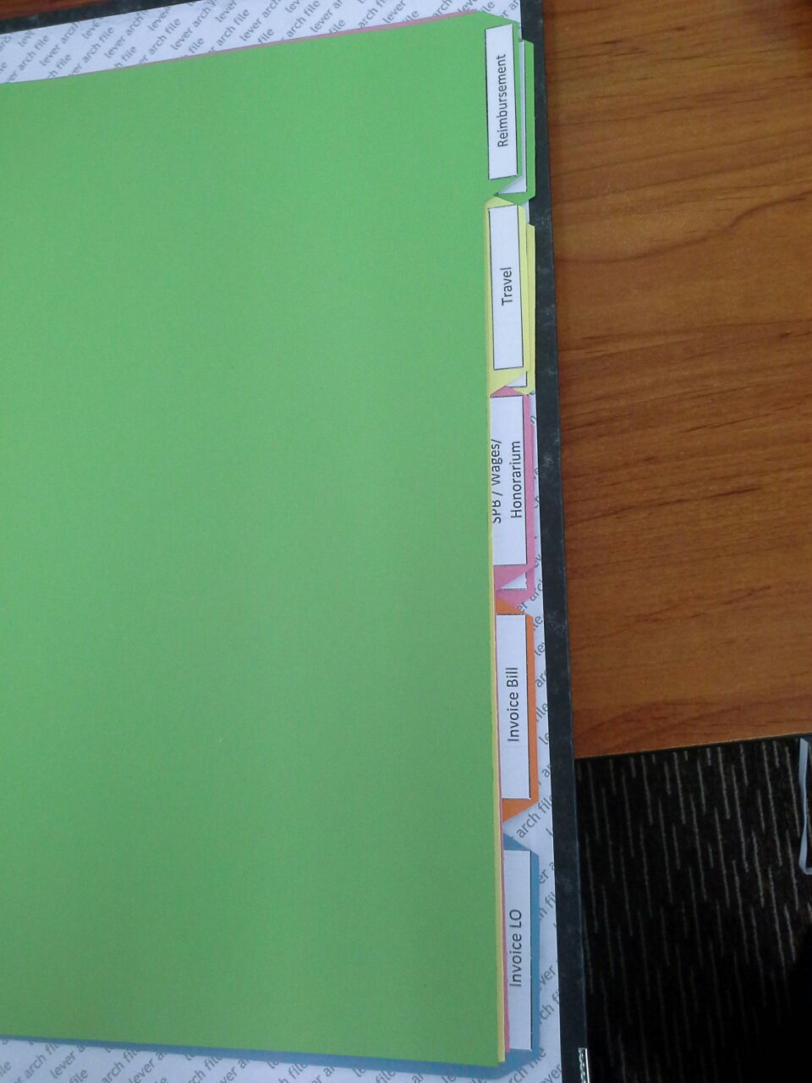

- Check and monitor the progress of the payment regularly by referring to Payment Status menu as shown below:
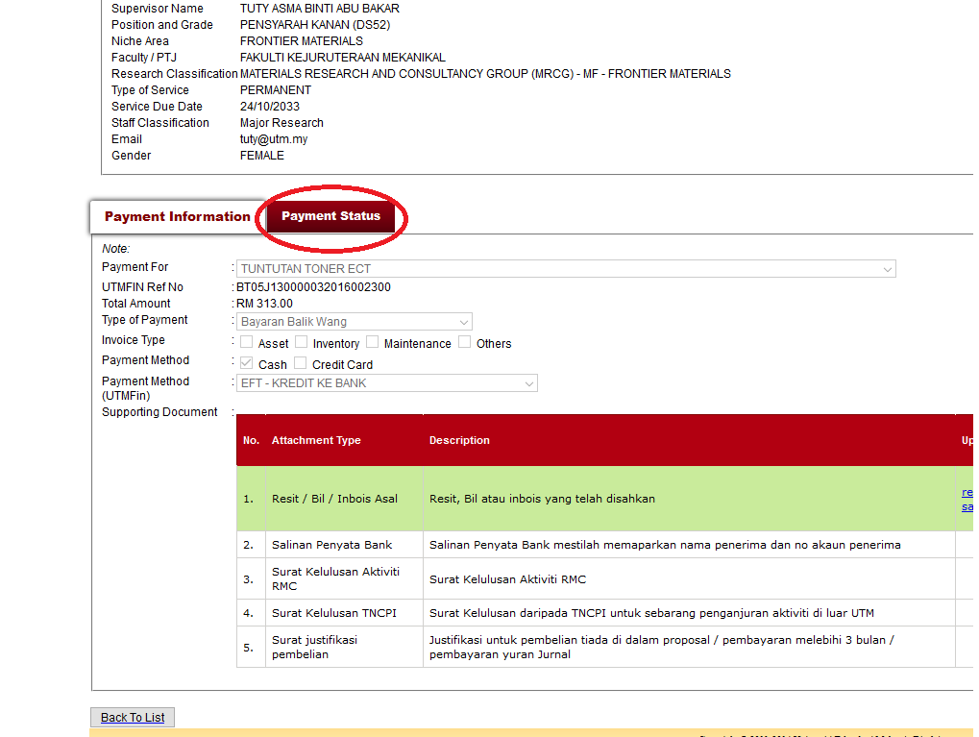

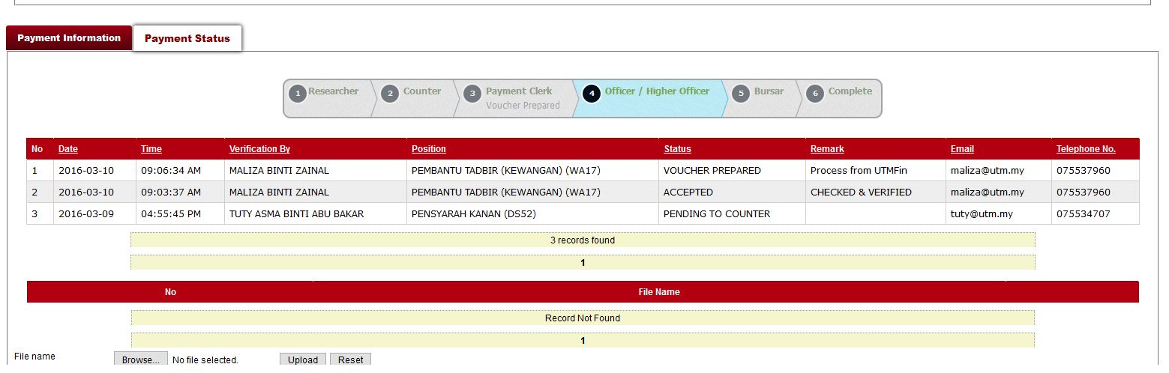
- Kindly ensure all necessary actions were taken (if required) by referring to remark field to speed up the payment process and contacting the staff for further inquiries.

Note:
- Kindly as Project Leader, you read all relevant and related Circulars and guidelines.
- Kindly make sure all the original documents were kept in Document File as soon as posibble to avoid any misplacing or document lost.
- Kindly refer to RMC Portal or go to http://rmc.utm.my/ for downloading Guideline for Preparation on Document Fail (Online Claim & Payment)
- Kindly give immediate respond if your file or project being audited if there are any inquiry arise in order to avoid any salary deduction.
- Kindly forward your suggestion, inquiries or even complaint to RMC Help Desk by go to http://www.rmconline.utm.my/Helpdesk.html or by click here.

