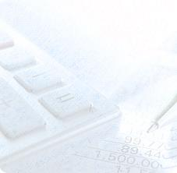

**GUIDELINE PREPARATION ONLINE CLAIM & PAYMENT DOCUMENTS FILE**

RESEARCH MANAGEMENT CENTRE 2016



1. Definition of Document File
2. Necessity of Preparing The Document File
3. Materials & Methods of Preparing File
4. Format & File Template
5. Storage of Document File

**ISI KANDUNGAN**

RESEARCH MANAGEMENT CENTRE 2016



**A. DEFINITION**

**B. NECESSITY OF PREPARING FILE**

RESEARCH MANAGEMENT CENTRE 2016

1. Every Project Leader are required to prepare Document File in order to filing the original documents after the documents scanned and uploaded into RADIS system.
2. As an alternative, Project Leader may place an order ready-made Document File from Account & Asset Record Unit, Finance Department of RMC. Project Leader may instruct vote transfer as instruction of payment or make a payment by cash as settlement.
3. The File Documents should be prepared according to the format and specification stated in this guideline in order to assist traceability, accessibility, distinguish and for standardization purposes.
4. The Document File must be taken care and being stored according to clause 6.0 Bursary Circular No.2.2015.

Document File can be define as one file or many files to store and keep all original supporting which being scanned for online claims & payments and all related supporting documents such as receipts, invoices, bills, approval letter, statement etc. – Bursary Circulars No 2.2015

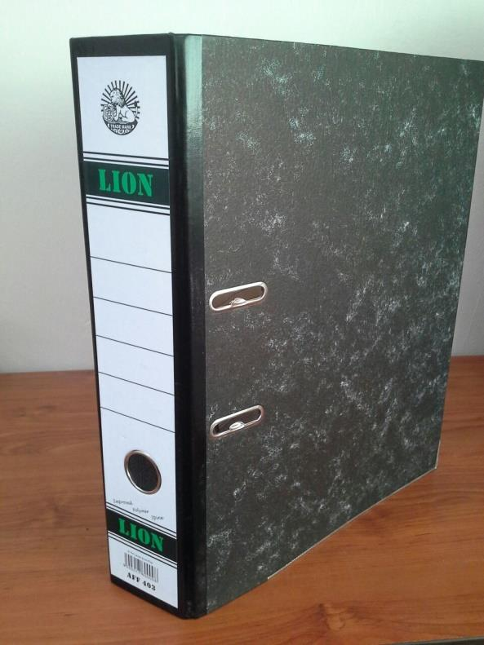

**C. MATERIALS & METHOD OF FILE PREPARATION**

Pic 1 – Black Hard Cover File

1. Project Leaders are strongly encouraged to use materials stated in this guideline in preparing the Document File.
2. Materials and tools used in preparing the Document File as stated below :
3. Black Hard Cover File
4. A4 Size of Sticker Paper
5. Coloured Separator Paper
6. Printer Colour

RESEARCH MANAGEMENT CENTRE 2016

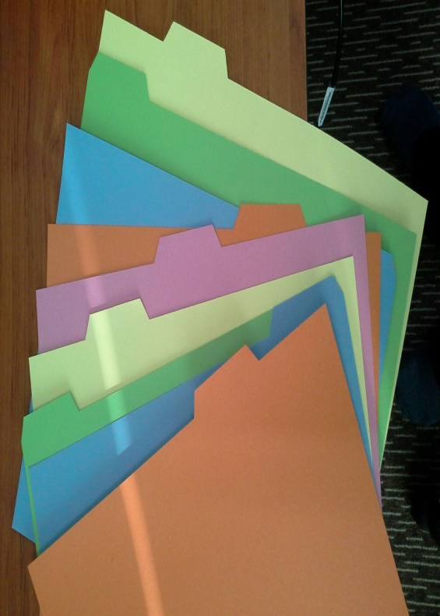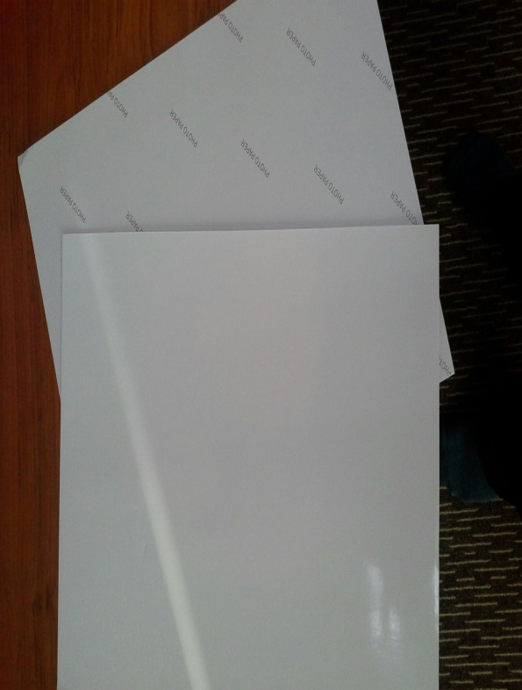

Pic 3 – Coloured Separator Paper

Pic 2 – A4 Sticker Paper

RESEARCH MANAGEMENT CENTRE 2016



1. For the front cover of the file, Project Leader are required to use a template which provided by RMC and can be downloaded from RMC Portal or by click [here](http://rmc.utm.my/download/finance-utmfin-user-manual/?wpdmdl=5376&ind=FnPG3bGnOCHMIEw7rwUX3Ctx2qptb0kXcT5uInOVwZzvV7MreNEqeR_LQmaubJymnghlWM_Kfglx6q4QySqdAw).
2. The template of front cover can be opened and modified by using Microsoft Publisher 2010.
3. Method of preparing the Document File can be followed sequentially as stated below :
4. To provide and prepare all materials as stated in (C - 2.)
5. To download the template of front cover as mentioned above in (D - 3.)
6. To ensure difference file is being prepared for each research project so that the original documents were filed accordingly, did not mixed each other and create confusion in tracing the document if required.
7. Updating the contain of the template such as the title of project, name of Project Leader, project period and date of extension (if any).
8. Print updated Front Cover of Document File on sticker paper using printer colour and paste it neatly on the front of the file. Refer Pic.4
9. Updating the Side File Template in Appendix 1 and print it on sticker paper using printer colour. This Is for the purpose of traceability of the file, and is a form of File Standard when the file returned to RMC once the project ended.
10. Cutting the updated Side File Template with tidy and neatly paste it on the side of the file as shown as Pic 5.
11. Print the Type of Claim as in Appendix 2 on sticker paper and paste it on each separator paper like shown by Pic 6.
12. If the content of the file was full, Project Leader may prepare the new file and change VOL to VOL 2. Alternatively, Project Leader may order from Account & Asset Record Unit as mentioned in (B-2).

**D. FORMAT AND FILE TEMPLATE**

RESEARCH MANAGEMENT CENTRE 2016

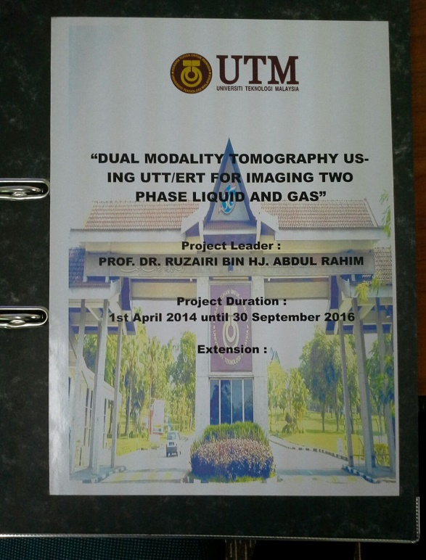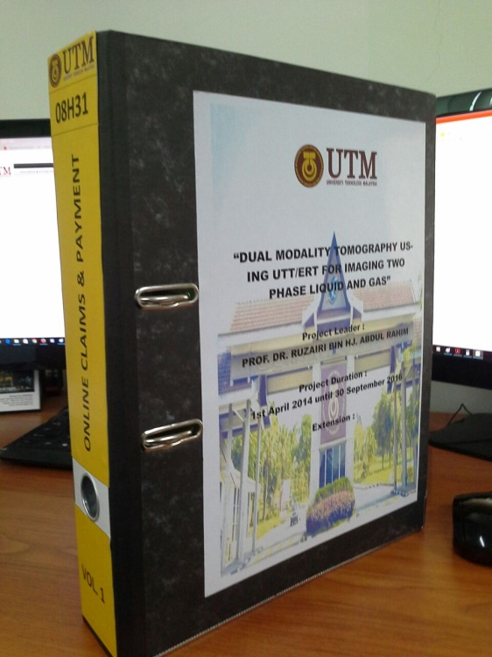

Pic 4 – Front Cover File

Pic 5 – Side Document File

RESEARCH MANAGEMENT CENTRE 2016

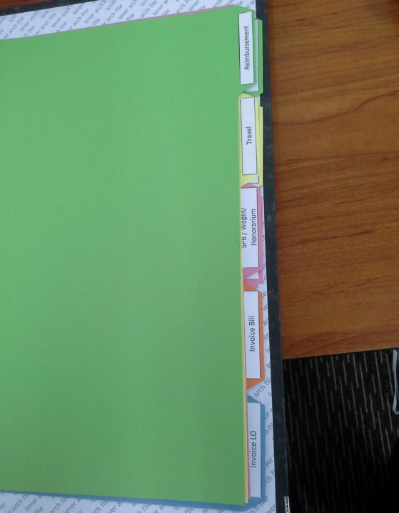

**E. STORAGE OF FILES**

1. Project Leader may refer to clause 6.0 Bursary Circular No. 2.2015 for more detail on how to store Document File in proper way.
2. Project Leader are strongly advised not to let the Document File under the care of students, or any individual which unrelated to the project in order to avoid manipulation of financial information.
3. Document File must be stored in a safe and locked place, as well as easy to access for regular updating and checking.
4. Project Leader are also strongly advised to instantly kept all original documents right after scan them into digital document or once click submit button in order to avoid the original document to be misplaced or lost.
5. Project Leader are also advised to always be ready for any Audit Session conducted by either by RMC, Bursar Office, Internal Audit or any Authority from Government Department.
6. Document File only can be returned and accepted by Finance Department once Final Report for the particular project was submitted and verified in RADIS system.

Pic 6 – Tagged & Coloured Separator Paper

RESEARCH MANAGEMENT CENTRE 2016

APPENDIX 1 – SIDE FILES TEMPLATE



**08H31**

**ONLINE CLAIMS & PAYMENT**

**VOL. 1**

RESEARCH MANAGEMENT CENTRE 2016

APPENDIX 2 – TYPE OF CLAIMS

|  |
| --- |
| Reimbursement |
| Travel |
| SPB / Wages / Honorarium |
| Invoice Bill |
| Invoice LO |
| Invoice UTM |
| Advance |
| Procurement |
| Asset & Maintenance Forms |

RESEARCH MANAGEMENT CENTRE 2016

RESEARCH MANAGEMENT CENTRE 2016