TEMPLATE AND INSTRUCTIONS FOR FORMATTING I-PHEX EXTENDED ABSTRACT

Wan Akmal Izzati Wan Mohd Zawawi*, Fatin Aliah Phang
Centre for Engineering Education,
Universiti Teknologi Malaysia,
81310 Johor Bahru, Malaysia
wa.izzati@utm.my
Introduction
To ensure that all articles have a uniform appearance, authors must produce a Word document (.doc or .docx) that meets the formatting specifications outlined here. The document will be used for both the hardcopy and electronic versions of the abstract book.
This document briefly describes and illustrates the extended abstract format. Below is the outline of the contents and basic specifications which includes font sizes, margins, etc.
Contents of the Extended Abstract
The extended abstract (around 1000 words) explains the innovative practices, such as the following:
- Problems or issues faced in teaching & learning in higher education that called for the innovation
- Educational theories or references underlying the innovation
- Describe the innovation and how it solves the problems in teaching & learning mentioned initially
- Research or evidence of the impact of the innovation towards teaching & learning
Style and Format
Papers must be printed in double column format as in this template. Margins should be 0.7 inch left and right, which will make the width of the column 3.3 inch and spacing 0.5 inch. Headers and footers should be 1/2 inch from edge. Title should start at the first line from the top of the page.
Fonts
Arial Narrow style fonts in 10pt type for the title, headings, and body text should be used.
Title and Authors
The title appears near the top of the first page, centered. Authors' names, affiliations, complete addresses, and corresponding author’s email address should appear right below the title of the paper. The corresponding author name should be marked with an asterisk (*) at the end of the name.
Headings and Sections
When necessary, headings should be used to separate major sections of your extended abstract. First-level headings should be in bold type and second-level headings should be in italic type. Do not skip a line between paragraphs. All headings should be in 10pt spacing before and capitalized. After a heading, the first sentence should not be indented. A section heading should never immediately follow another section heading without intervening text.
Figures and Tables
Figures and tables should be inserted in proper places throughout the text. Do not group them together at the beginning of a page, nor at the bottom of the paper. Number figures sequentially, e.g., Figure 1, and so on.
Table number and the caption should appear above the illustration. Figure number and the caption should appear under the illustration. Leave a margin of one-quarter inch around the area covered by the figure and caption. Captions, labels, and other text in illustrations must be in 9pt bold type.
Some types of illustrations in manuscript may cause problems for some printers/previewers. Although this is gradually becoming less of an issue, authors are encouraged to use “reliable'' programs for producing figures. Before the paper can be accepted, it must be verified that all the figures can be printed successfully and may be viewed with Adobe Acrobat Reader.
Table 1. Note that I-PHEX Extended Abstract table captions above the table 9pt bold font
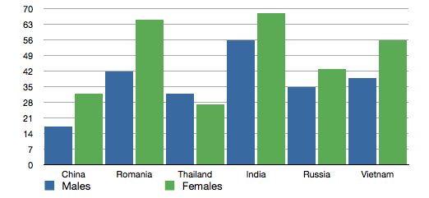
Figure 1. Note that I-PHEX Extended Abstract figure captions below the figure 9pt bold font
Acknowledgement
The acknowledgement section appears after the main body of the text and is headed ``Acknowledgement''. The section should not be numbered. This section includes acknowledgement of help from associates and colleagues, financial support, and permission to publish.
References
Please use 6th edition APA referencing style.
References
Plint, M. & Martyr, A. (2007). Engine Testing: Theory and Practice. Oxford: Butterworth Heinemann.
Babbit, G.R., Bonomo, R.L.R. & Moskwa, J.J. (1997). “Design of an Integrated Control and Data Acquisition System for a High-Bandwidth, Hydrostatic, Transient Engine Dynamometer”. Proceedings of the 1997 American Control Conference, Vol. 2, 4-6 June, 1157-1161.

